NiKO Trade CZ Ltd. Galaxtonez Limited s.r.o.

Klimentská 1216/46 Plzenská 2

110 00 Praha 1 080 01 Prešov

Czech Republic Slowakia

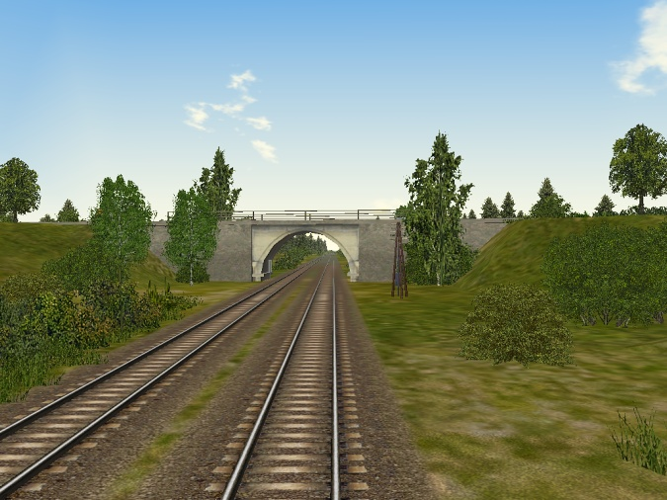

FEASIBILITY STUDY

" PROJECT OF RAILWAY CONSTRUCTION BERBERA-DIRE DAWA "

*********** Prague, May 2019

CONTENT

Annotation

Annotation sheet of the project

Risks and benefits of the project

Presentation and justification of the project

Market analysis and marketing concept

Individual project elements for project implementation

Localization of the project

Technical and material solution of the project

Organization structure and overheads of the project

Human resources

Schedule of the project implementation

Economic analysis

1. Annotation

In May 2017, DP World (United Arab Emirates) signed a contract with the Government of the Republic of Somalia for the reconstruction and construction of Berber Harbor. DP World will invest in the construction of a new harbor and reconstruction of the old port amounting to 433 million dollars. The government of the Republic of Somalia, on the other hand, will allow DP World to manage the port for 30 years. In February 2017, Etiopian Railway completed the reconstruction of the railway line between Djibouti Harbor and Ethiopia's capital Addis Ababa. This railroad has become the only link for the transport of goods and material to Ethiopia for the maritime transport of goods. The purpose of repairing and building a port in Berber is to boost maritime transport of goods to Ethiopia in order to reach a capacity of 1.75 million tons of goods and material per year. To achieve these transport parameters is the construction of a high-quality double-track railway from the port of Berber to Dire Dawa in Ethiopia where the Addis Abeba-Djibouti railway line leads. This track will greatly facilitate Ethiopia's access to maritime goods transport and will relieve the overloaded railroad from the port of Djibouti. At the same time, the construction of the Berbara-Dire Dawa railway will make it easier for people to travel between Somaliland and Ethiopia and create prerequisites for connection to the East African railway system building system with the possibility of connecting the Addis Ababa railway via Chartum to Cairo and further to Alexandria, Linking East Africa with the Mediterranean by land by rail.

Annotation sheet of the project

Project name | PROJECT OF RAILWAY CONSTRUCTION BERBERA – DIRE DAWA
Territory | Somaliland (Somalia, northern Somalia)
Objective and intent of the project | Construction of a two-track railway line between the port, Berber and the Hargeisa city. Hargeisa city of Somaliland with a rail link in Dire Dawa, Ethiopia
The type of bussines | Turnkey delivery of the entire project, including deliveries of appropriate technologies and railway wagons including locomotives
The contract party | NiKO Trade Ltd.  NiKO Trade CZ Ltd. organizational unit  Galaxtonez Limited s.r.o.  Or, a new company will be established for this project
General contractor | Coordination of the preparation is carried out by:  NIKO TRADE CZ LTD  Galaxtonez Limited s.r.o.  Czech-East African Chamber of Commerce
Subcontractors | - NiKO TRADE CZ LTD - project developer, coordination of  preparatory work  - The capital company, which will make financial input to the plan -  is not currently selected  - Companies that will produce individual units of railroad  construction - is currently not selected  - The company that will perform the geological survey and the  overall preparedness of the project including the construction of  the subsoil for the railway line - is not currently selected  - The company that will manage the operation of the railway line –  is not currently selected
Financing method | Project financing  1. From own resources  - before project preparation  - elaboration of sub-projects of railway stages  - Ensuring all contracts needed to implement the plan  - conclusion of the sale contract in Somaliland  2. Entering the capital company into the overall plan.  - Funding a complete track management survey  - The actual construction of the track including the necessary  technologies  - Financing of rolling stock including locomotives  3. Possibility to consider the participation of the African partner in the  financing and implementation of the whole project.
The total price of supply | Total: US $ 3.500 million
The date | Start the whole project 08/2019
 | Presumption of bid | 09/2019 - 10/2019
 | Closing all contracts | 11/2019 – 12/2019
 | Own construction and commissioning according to individual stages  Commissioning | 01/2020 - 12/2022
Project Investigators | Czech-East African Chamber of Commerce  Omar Yussuf Hussein  NiKO TRADE LTD and NiKO TRADE CZ Ltd.  Ing. Ivan Svoboda  Galaxtonez Limited s.r.o.  Jan Růžička

- Risks and benefits of the project

Main factors that represent strengths and weaknesses of the project, opportunities and threats are:

Strenghts | Weaknesses
- Clear Ownership  - The High quality basement of raw materials  - Location near the port of Berbera  - Possibility of relatively cheap energy inputs  - Practically no administrative restrictions | - The technical standard of the original equipment (in particular, before homogenization)  - Technical documentation of the original building construction is not exists
Opportunities | Threats
- The price of cement is very high and still increasing  - Possibility of constructing a new modern line without participation in the competition - procedure  - Presumption of a stable and peaceful political situation in accordance with the preparation of building a U.S. military next to Berbera | - The Republic of Somaliland is not internationally recognized  - Some possibility of terrorist attacks (very unlikely now, given the stability of the government of Somaliland)  - According to the OECD classification the Somaliland is 7th risk group and it is uninsurable country

- Presentation and justiifcation of the project

In 1994, Ethiopia lost a civil war with Eritrea, and Eritrea declared independence. This Eritree step was agreed upon by the international community, and gradually all Eritrean states recognized it as an independent and sovereign state. But with this step, Ethiopia cut off from the sea and became a land-based state, which is a major problem for nearly 90 million countries because Ethiopia has used ports in Eritrea for its export and import affairs. After the end of the civil war, the only rail link to the Ethiopian Sea was the old railroad built by Italy, which connected Addis Ababa and the port of Djibouti. The construction of the Djibouti-Ethiopian Railway linking Djibouti with Ethiopian Addis Ababa, with a total length of 781 kilometers (of which 121 in Djibouti), began at the end of the 19th century and was completed after twenty years with the contribution of France. The common Ethiopian-Djibouti ownership of the railway confirmed the 1981 and 1985 contracts. The European Union promised part of the reconstruction, but its contribution of USD 100-200 million is only a fraction of the cost of complete rehabilitation of the track (estimates indicate a need of USD 1.5 billion. ). In August 2009, however, the Ethiopian government unilaterally denounced the treaty with the EU for the reconstruction of the line.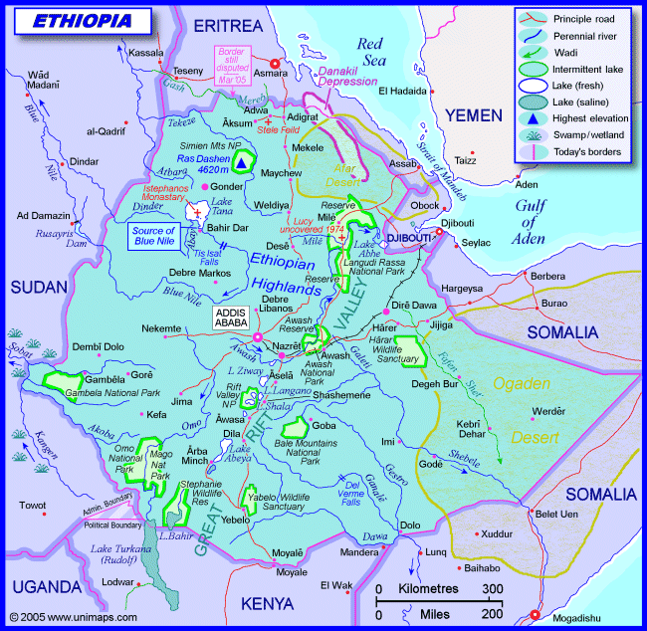

In 2008 interest in cooperation with the Czech Republic in the field of supply for the construction of the railway network Ethiopian railway company Ethiopian Railways. The project is planned for the next seven to ten years. The company has already begun to address specific Czech companies, some of which have shown interest in participating in the project. "The offer could be interesting for the experienced domestic companies that have already been involved in building the railway, for example in the Balkans, Montenegro or Croatia," said Milan Mostyn, spokesman for the Union of Industry and Transport. But since then no one has ever heard from Ethiopian Railways.
A plan for the construction of a East African Community (EAC) regional rail network was launched in 2009, becoming realistic with the establishment of the East African Railway Authority (EARA). The total project is estimated at $ 29 billion. The first real step was to set up and approve the budget for the effective operation of EARA of $ 1.8 million.
The main task of EARA will be to revive and implement the so-called East African Railway Master Plan. The plan was established in 2009. The basic feature of the project will be the transition from the colonial railway gauge of 1 000 mm to the international standard of 1 435 mm, which will allow the acceleration of the goods transport time as well as the capacity. The transition to the standard gauge should increase the capacity of the transported goods from the current 3.7 million tons to 16-35 million tons in 2030. Today, only 10% of the cargo is transported by rail in the EAC countries compared to a potential of 70%.
Another major challenge for EARA will be to assist in obtaining the necessary funding where the key incentive for investors will be a combination of the temptation of the stable economic development of the region in recent years and an increased emphasis on the implementation of this project by the EAC and partner countries of Ethiopia, South Sudan and the Democratic Republic of Congo. Among the major financial partners, alongside the African Development Bank, will be the European Development Bank, Japan International Cooperation Agency and some Chinese companies.
The first is to implement a project to build a Dar es Salaam-Tabora-Mwanza rail link in Tanzania and rehabilitate the Voi-Taveta link between Kenya and Tanzania, linking two lines heading eastward. NB: These projects have already been agreed at the EAC member countries' summit in December 2012.
Continue with rehabilitation and transition to the standard Mombasa-Nairobi-Kampala railway track, construction of the Lamu-Isiolo-Moyale-Addis Ababa railroad with Isiolo-Nadapal-Juba and Nairobi-Isiolo. These connections will also connect East African Railways with Ethiopia and South Sudan, as well as Djibouti reconstruction of the Addis Ababa-Djibouti railway (the USD 2.9 billion financing deal with the Chinese EXIM Bank was successfully concluded). The construction of the Nairobi metropolitan transport system also includes the already established connection between the city center and Joma Kenyatta International Airport.
Modernization of the existing colonial line from Dar es Salaam to the capital Dodoma and further to Rwanda, Burundi, Uganda and the DRC is to begin already this year. The realization of the Dar es Salaam-Isaka-Kigali / Keza-Gitega-Musongoti project for an estimated $ 5.2 billion should then take approximately four years to bring about a significant reduction in transport costs for Rwanda and Burundi.
Railway construction in this part of Africa, which was under British colonial administration, offers a large number of export and, eventually, investment opportunities. All the countries of the region record stable economic growth, ranging from 5-8% per year, and at the same time there are significant findings of mineral resources. The population of the East African Commonwealth (Kenya, Tanzania, Uganda, Rwanda, Burundi) is approximately 140 million. In addition, Ethiopia (99 million inhabitants), South Sudan (10 million inhabitants), Zambia (14 million inhabitants), Malawi (15 million inhabitants) and the eastern part of the DRC (five million) are also attributed to the wider East Africa transit area Downward provinces with about 25 million inhabitants, all of which are countries with significant mineral wealth and growing agricultural production.
In October 2016, the reconstruction of the Djibouti - Addis Ababa railway line was completed by the Chinese investor and was officially opened in February 2017. However, the monorail line does not have the chance to carry the expected amount of goods and material and it will be necessary to open at least one access to a port. It offers ideal conditions for the port of Berber in the Republic of Somaliland.
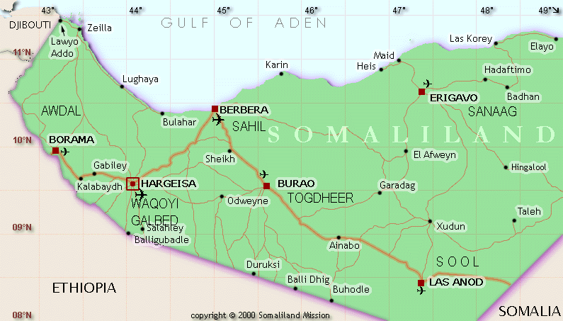

The subject of the project is the complete construction of a new railway in two stages:

Berbera – Hargeysa
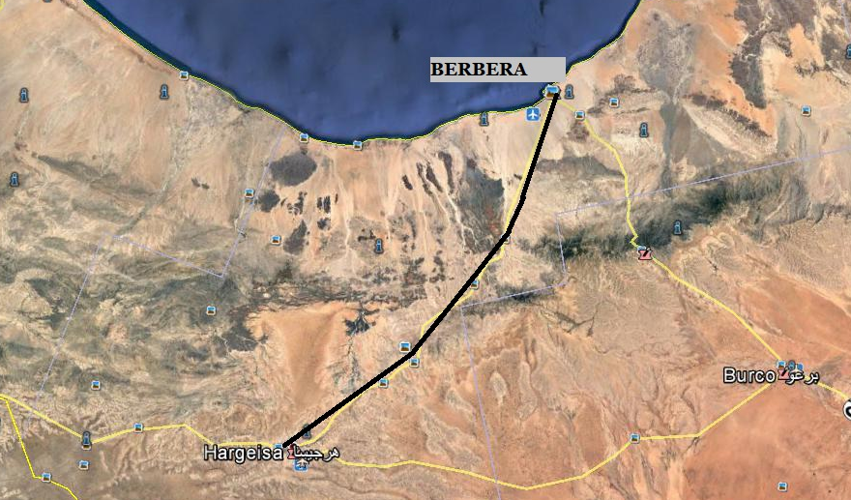

The length of the construction of the first stage of Berber-Hargeysa will be about 160 km of double-track Routes. The elevation along the entire length of the route will be about 1450 meters above sea level. Berbera is a very important port in the Gulf of Aden and is the second. The largest port of Djibouti. In the 1970s-80s of the last century, Soviet Union used the harbor as a naval military base. Nowadays Is a very important traffic artery for goods flowing into Ethiopia. Considering To the fact that, since World War I, the port has not been extensively expanded and Reconstructed in 2013, the French company Bellore Africa has close Logistics Agreement with the Government of Somaliland on the intention to invest in modernization Port 500 million USD. Unable to implement this intention. May 2017 Was signed by DP World (United Arab Emirates) with the Republic Somaliland investment contract for the complete reconstruction of the harbor of 442 Million USD. The Berber port will certainly become an important starting point For rail to Ethiopia.

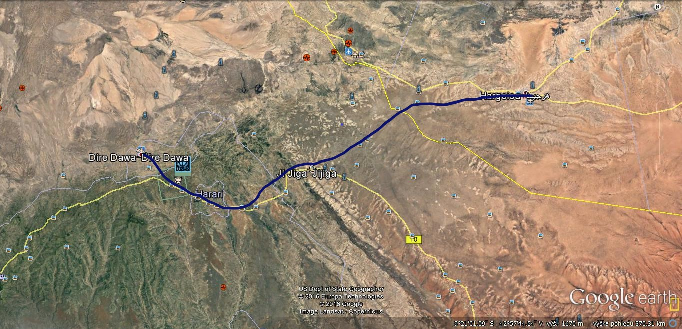
- Hargeysa – Jijiga (Etiopie) - DIRE Dawa (Etiopie)

The length of the second stage is 340 km of two-track routes and the cant is very small because the construction is on the plateau.

- Market analysis and marketing concept

No railway line is currently in operation in Somaliland. From the point of view of competition, the nearest Djibouti - Addis Ababa rail link, where the monorail railroad was reconstructed in 2016 and reopened in February 2018, is the closest rail link. This is a shipping line for Ethiopia from Djibouti.
Planned construction of the new railway line Berber - Hargeisa - Jijiga - Dire Dawa
The old railway line Djibouti - Addis Ababa built in 1897 and renovated in 2017
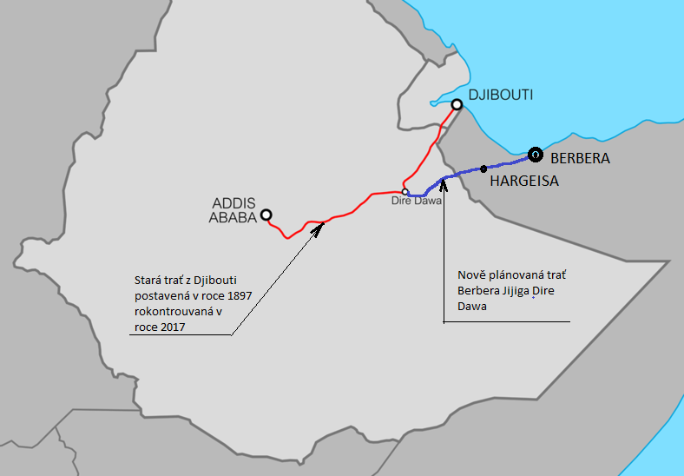
At present, 6.5 million tonnes a year are transported from the port of goods. The reconstructed Djibouti-Addis Ababa railway will have a total of 1.4 million tonnes of goods a year, the rest being transported by road. The construction of the Berber-Dire Dawa railway can cover between 3 and 4.5 million tons of goods a year in a purely containerized transport.
Everything depends on the modernization of the port of Berber, if the company's goal is to modernize the port by carrying capacity of 10 million tons of goods per year, the construction of the Berber-Dire Dawa railway is very effective, because the construction of the road infrastructure would be significantly more expensive, with complicated financial returns .

- Individual project elements for project implementation

The individual elements of the project are:

- Basic preparatory work for railway construction, geological exploration in certain localities,
bridging and railway establishment
- Gradual work on the foundation of the railways
- Installation of the railway superstructure, including security technologies, by stages:
1) The first stage of the Berber railway station and the construction of the railway to Hargejsa
2) The second stage of construction of a transfer station in Hrageisa and the construction of a
railway to Jijig with the construction of a border checkpoint on the border with Ethiopia
3) Third stage construction of the last section of Jijiga - Dire Dawa with the construction of a
dama in Dire Dawa (consolidation with the government of Ethiopia)
- Purchase of rolling stock including locomotives
- Construction of railway stations and individual stations for passenger transport
- Construction of terminal loading and unloading in the port of Berber, Hargejsa and Dire Dawa
- Construction of a service depot in Berber and Hargeis

- Localization of the project

The location of the project is determined by its own structure. From the port of Berber to the capital of Hargeis on the border with Ethiopia and further to the city of Jijig and further to Dire Dawa.

Because of the localization of the project, it will have to be discussed with both the Republic of Somaliland and the Ethiopian government, but due to the importance of the entire construction, no problems are expected.

- Technical and materiál solution

The geological survey will be carried out on the basis of an agreement with the Gemological Institute of the Academy of Sciences of the Czech Republic in Ostrava. This institution has already carried out geological surveys in Somsliland in recent years and knows the geological structure of the entire territory.

Based on a geological survey, fieldwork will be carried out for the subsoil of railway tracks.
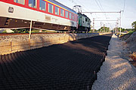
For landscaping, a classical technique for earthworks will be needed, which will be delivered along with the foundation elements. Establishment will be based on new technology from Benda Trade a.s. WEBFLOOR system. Technology is clearly the cheapest and technologically best for setting up a railway line.
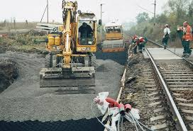
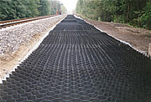
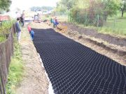

WEBFLOOR folding is greatly saves financial and is considerably more robust than traditional layout.

The sleepers will be concrete and will be produced directly in Berber, Somaliland, on the premises of the former cement plant.

The Railway track superstructure will be imported from both the Czech Republic and China. A complete attachment element to the concrete sleepers will also be part of the rail supply. The Třinecké železárny a.s. company, which traditionally supplies rails with all the elements, will be approached as a delivery set. The tender will be announced for delivery as well.

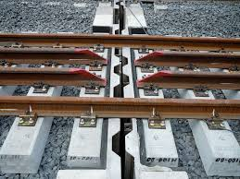
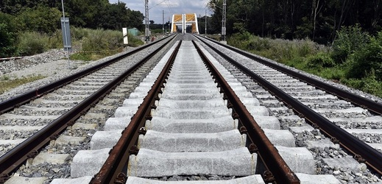
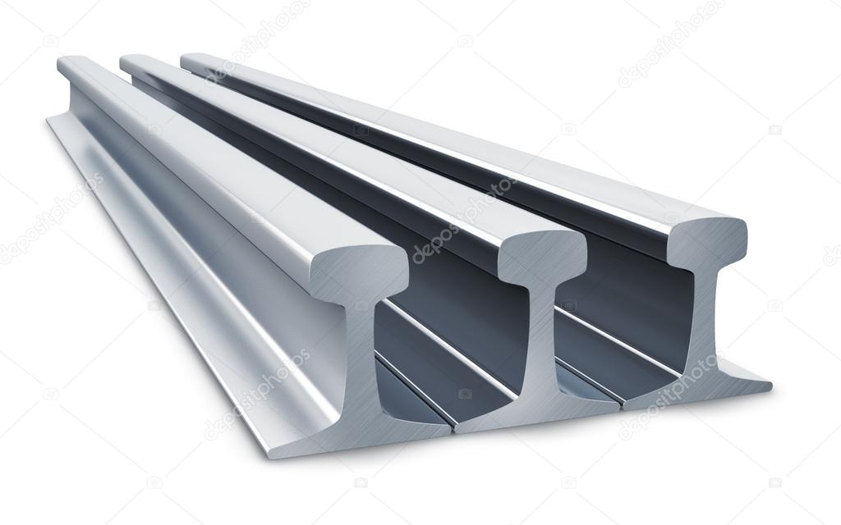
The spreading material will be a material from Somaliland, it will be necessary to supply special crushing machines for stone crushing. For concrete sleepers, crush is commonly used in parameters 15 – 25 mm.
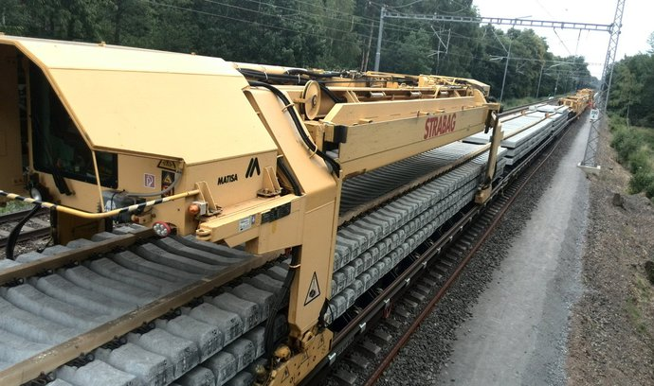
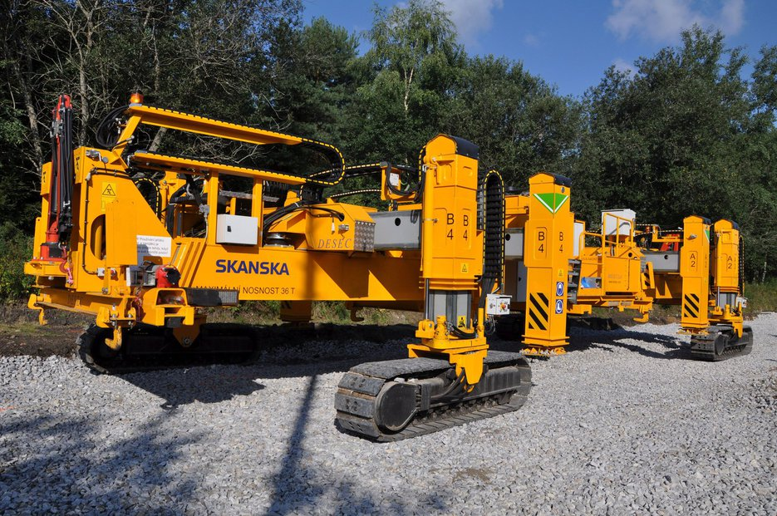
Special machines will be required to install the railway superstructure:

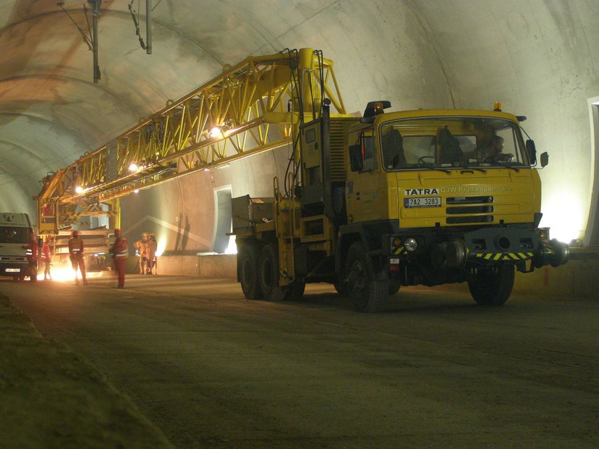

To ensure the efficient operation of the railway line, the necessary amount of rolling stock needs to be ensured.
Rolling stock:
Motor traction locomotives:
For the drawing of container trains, we offer very powerful locomotives from Siemens:
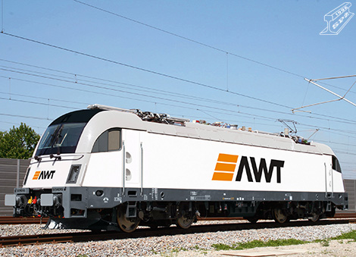
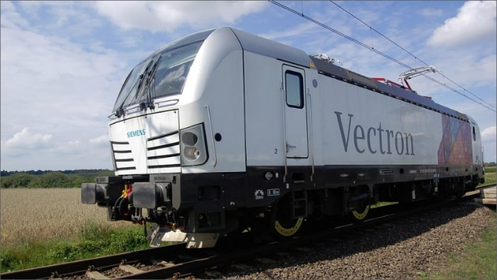

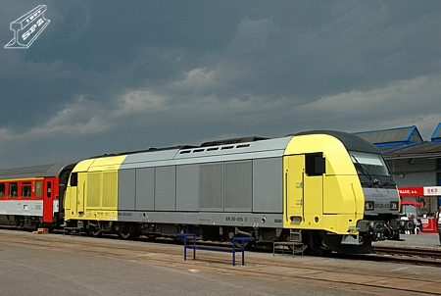
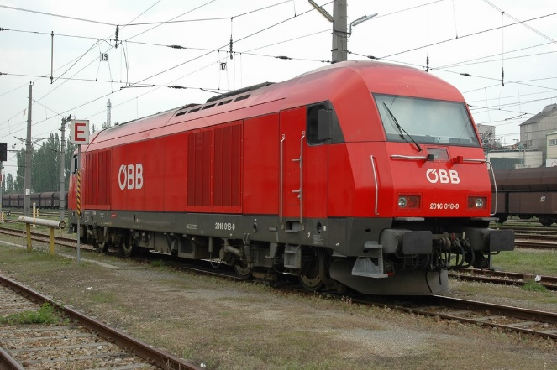

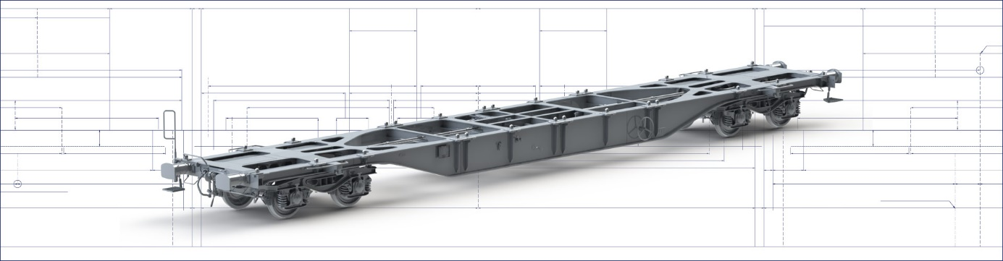
Platform wagons for container transport:
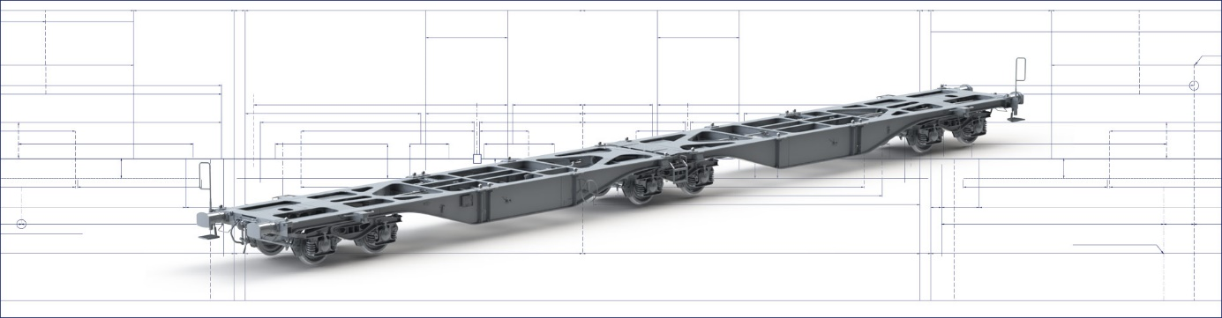
Shark train units are available for passenger transport.
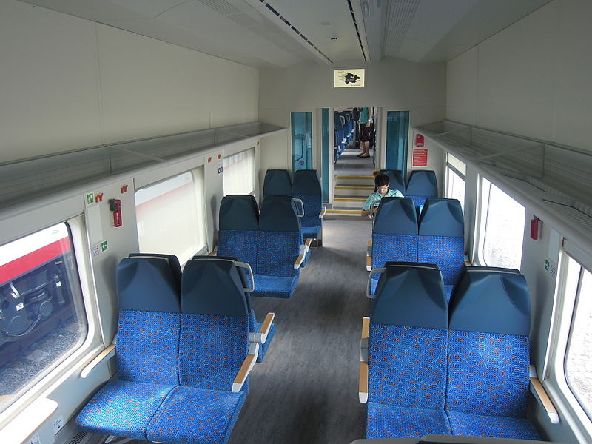
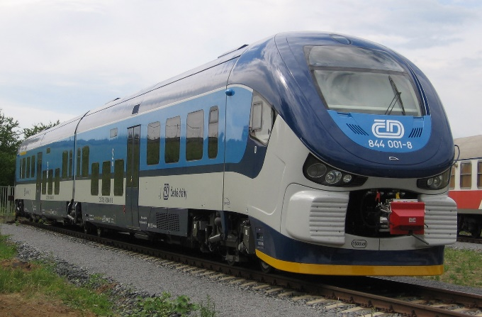

- Organization structure and overheads of the project

To ensure the realization of the project "Construction of the Berber-Hargeisa railway line. Jijiga - Dire Dawa "and its subsequent operation, it is proposed to establish a separate legal entity (eg a joint stock company) called QORRAHEY RAILWAY LTD. This legal entity will be established during the preparation of the whole project and its majority shareholder will be the investor organization and NIKO TRADE LTD . And the minority shareholder will be a state organization designated by the Government of the Republic of Somaliland. After 30 years of operation, the government will take 70% of the shares free of charge into its property, 15% will remain to NiKO Trade Ltd. And 15% to the investor.

The Company's expected capital ratio will be:

1. Selected investor 75%
2. NiKO Trade Ltd. 15%
3. Somaliland 15%

Construction will be carried out by NiKO Trade Ltd. On the basis of a closed investor agreement with the selected investor.

During the implementation of the project QORAAHEY RAILWAY LTD. The investor's capital will be gradually returned on the basis of the concluded contract. As the capital of an investment company is returned, the investor's share capital in QORRAHEY RAILWAY LTD will be reduced. Once the entire value of the capital is returned to the investor, the General Meeting will meet and determine the capital structure of QORRAHEY RAILWAY LTD., So that the structure is as follows.

1. Selected investor 15%
2. NiKO Trade LTD. 15%
3. Somaliland subject 70%

During construction, a system of funds flow from the investor will be established based on approved protocols for the needs of individual stages of implementation. All invoicing will be made through NiKO Trade Ltd. With the consent of the selected investor.
Every half year, NiKO Trade Ltd. To the selected investor an overview of the use of the funds provided by the selected investor.

- Human resours

For the construction of the railway line, the necessary number of employees will be selected at the individual locations, who will become employees of NiKO Trade Ltd., this company will pay all legal fees for the workers. Today, Somaliland, as well as everywhere in Africa, has a high unemployment rate and will not make it a problem for the construction of a railway line to provide the necessary staff from local sources.

During construction, it will be necessary to train the necessary number of workers for the operation of the railway line. These trained employees become employees of QORRAHEY RAILWAY LTD ..

We will work with the Technical Institute in Burao Republic of Somaliland to train new specialists in the railway industry.

11. Schedule of the project implementation

Start the whole projekt 08/2020
Presumption of bid 09/2020 – 10/2020
Closing all contracts 11/2020 – 12/2020
First stage: Berbera - Hargeisa
- Geological work 01/2021 - 02/2021
- Processing of Implementation Document 03/2021
- Starting of earthworks 04/2021
- Construction of the railway line 05/2021 - 12/2022
Second Stage: Hargeisa - Dire Dawa 01/2022 - 12/2023

12. Economic analysis

The assumption is that the track will be two-railways and will be usable both for passenger and freight transport.
A total of 10 new or stop stations will have to be built and one (Dire Dawa) reconstructed.
Stop where it will be necessary to build a new railway station:
- Berbera and the terminal in the harbor, a branch to the cement plant will be built
- Mandera
- Daarbuduk
- Daarbuduq
- Awbarkhadle
- Hargeisa (railway station and freight dock)
- Gadka Yogol
- Alley Badey (border crossing Somaliland - Ethiopia, freight station)
- Jijiga
- Babile Babile
- Harar Harar
- Dire Dawa (large dock)
At the moment, transport between Addis Ababa and the port of Djibouti is 6.5 million tons of goods in 2016.

The average cost of building 1 km of the railway superstructure, including the necessary equipment and equipment, will not exceed $ 6.0 million = about 480 km = $ 2,480,000,000.00.

Berbera would like to ship 25% of the quantity of goods and goods transported to Ethiopia after reconstruction of the port, ie 3.0 million tonnes of goods by rail.
Estimated income from passenger transport
 | Number of kits per day in both directions | Average number of passengers transported in train set | Estimated number of passengers per day | Average of passengers per year | Average cost of one ticket | Average turnover per year
Personal transport Hargeisa -Berbera | 8 | 300 | 2400 | 876000 | $10,00 | $8 760 000,00
Personal transport Hrageisa - Adis Ababa | 4 | 250 | 1000 | 365000 | $40,00 | $14 600 000,00

Estimated revenue from freight rail transport
 | Number of packages per day in both directions | Number of wagons in one set | One wagon is transported on average in tonnes | Price per 1 tonne of transported goods | Daily transported in tonnes | Daily turnover | Annual turnover | Annual carriage in tonnes
Freight container transport | 16 | 20 | 25 | $50,00 | 8 000 | $400 000,00 | $146 000 000,00 | 2 920 000

Overhead costs of station operation and transfer terminals
 | Number of employees on rail | average wage per week | Annual wage costs | Total costs
Labor costs | 1000 | 250 | $13 000 000,00 | $13 000 000,00
Railway maintenance estimate |  |  |  | $2 500 000,00
Fuel |  |  |  | $15 000 000,00
Other overhead costs |  |  |  | $5 000 000,00
Total overhead costs |  |  |  | $35 500 000,00
Purchase of technologies
 | Number of pieces | Price per unit | Total price
Traction technology | 1 | $15 000 000,00 | $15 000 000,00
Buying locomotives | 22 | $4 000 000,00 | $88 000 000,00
Purchase wagons | 240 | $92 500,00 | $22 200 000,00
PESA LINKII motor unit for passenger transport | 16 | $2 500 000,00 | $40 000 000,00
Total technology |  |  | $165 200 000,00

 |  | 2020 | 2021 | 2022 | 2023 | 2024 | 2025 | 2026 | 2027
1. | Total investment | $11 500 000,00 | $1 550 500 000,00 | $1 575 700 000,00 | $0,00 | $0,00 | $0,00 | $0,00 | $0,00
2. | Operating costs | $11 500 000,00 | $1 550 500 000,00 | $1 575 700 000,00 | $36 000 000,00 | $36 000 000,00 | $36 000 000,00 | $36 000 000,00 | $36 000 000,00
 | 2.1. Cash Expenditures | $11 500 000,00 | $1 550 500 000,00 | $1 575 700 000,00 | $36 000 000,00 | $36 000 000,00 | $36 000 000,00 | $36 000 000,00 | $36 000 000,00
 | 2.1.1. Construction of a rail superstructure | $0,00 | $1 480 000 000,00 | $1 400 000 000,00 | $0,00 | $0,00 | $0,00 | $0,00 | $0,00
 | 2.1.2. Overheads | $500 000,00 | $8 000 000,00 | $8 000 000,00 | $35 500 000,00 | $35 500 000,00 | $35 500 000,00 | $35 500 000,00 | $35 500 000,00
 | 2.1.2. Other costs | $1 000 000,00 | $2 500 000,00 | $2 500 000,00 | $500 000,00 | $500 000,00 | $500 000,00 | $500 000,00 | $500 000,00
 | 2.1.3. Preparatory work | $10 000 000,00 | $60 000 000,00 | $0,00 | $0,00 | $0,00 | $0,00 | $0,00 | $0,00
 | 2.1.4. Purchase of technology | $0,00 |  | $165 200 000,00 | $0,00 | $0,00 | $0,00 | $0,00 | $0,00
3. | Revenue | $0,00 | $0,00 | $21 600 000,00 | $179 360 000,00 | $179 360 000,00 | $179 360 000,00 | $179 360 000,00 | $179 360 000,00
 | 3.1. Sales | $0,00 | $0,00 | $21 600 000,00 | $179 360 000,00 | $179 360 000,00 | $179 360 000,00 | $179 360 000,00 | $179 360 000,00
 | 3.1.1. From passenger transport |  |  |  | $23 360 000,00 | $23 360 000,00 | $23 360 000,00 | $23 360 000,00 | $23 360 000,00
 | 3.1.2. From Freight Transport |  |  |  | $146 000 000,00 | $146 000 000,00 | $146 000 000,00 | $146 000 000,00 | $146 000 000,00
 | 3.1.3. Transit Fees |  |  |  | $10 000 000,00 | $10 000 000,00 | $10 000 000,00 | $10 000 000,00 | $10 000 000,00
4. | Net cash revenue | -$11 500 000,00 | -$1 550 500 000,00 | -$1 554 100 000,00 | $143 360 000,00 | $143 360 000,00 | $143 360 000,00 | $143 360 000,00 | $143 360 000,00
 | 4.1. Tax on profits | $0,00 | $0,00 | $0,00 | $7 168 000,00 | $7 168 000,00 | $7 168 000,00 | $7 168 000,00 | $7 168 000,00
 | 4.2. The net profit | -$11 500 000,00 | -$1 550 500 000,00 | -$1 554 100 000,00 | $143 360 000,00 | $143 360 000,00 | $143 360 000,00 | $143 360 000,00 | $143 360 000,00
 | 4.2.1. Interest | $0,00 | $0,00 | $0,00 | $0,00 | $0,00 | $0,00 | $0,00 | $0,00
 | 4.3. Net profit + interest | -$11 500 000,00 | -$1 550 500 000,00 | -$1 554 100 000,00 | $136 192 000,00 | $136 192 000,00 | $136 192 000,00 | $136 192 000,00 | $136 192 000,00
5. | Net cash flow | -$11 500 000,00 | -$1 550 500 000,00 | -$1 554 100 000,00 | $136 192 000,00 | $136 192 000,00 | $136 192 000,00 | $136 192 000,00 | $136 192 000,00
6. | Sources of financing | $11 500 000,00 | $1 550 500 000,00 | $1 575 700 000,00 | $0,00 | $0,00 | $0,00 | $0,00 | $0,00
 | 6.1. Investment | $11 500 000,00 | $1 550 500 000,00 | $1 575 700 000,00 | $0,00 | $0,00 | $0,00 | $0,00 | $0,00
7. | Financial commitments | $0,00 | $0,00 | $0,00 | $131 000 000,00 | $131 000 000,00 | $131 000 000,00 | $132 000 000,00 | $132 000 000,00
 | 7.1 Repayment of the investment | $0,00 | $0,00 | $0,00 | $130 000 000,00 | $130 000 000,00 | $130 000 000,00 | $130 000 000,00 | $130 000 000,00
 | 7.3. Dividends | $0,00 | $0,00 | $0,00 | $1 000 000,00 | $1 000 000,00 | $1 000 000,00 | $2 000 000,00 | $2 000 000,00
8. | Net cash balance | -$11 500 000,00 | -$1 550 500 000,00 | -$1 554 100 000,00 | $5 192 000,00 | $5 192 000,00 | $5 192 000,00 | $4 192 000,00 | $4 192 000,00
9. | Cumulative net cash balance | -$11 500 000,00 | -$1 562 000 000,00 | -$3 116 100 000,00 | -$3 110 908 000,00 | -$3 105 716 000,00 | -$3 100 524 000,00 | -$3 096 332 000,00 | -$3 092 140 000,00
„Integrated analysis of the construction of the Bereber-Hargeisa-Jijiga- Dire Dawa railway project“

