FEASIBILITY STUDY OF THE PROJECT

„RECONSTRUCTION OF THE CEMENT PLANT IN BERBERA“
THE REPUBLIC OF SOMALILAND

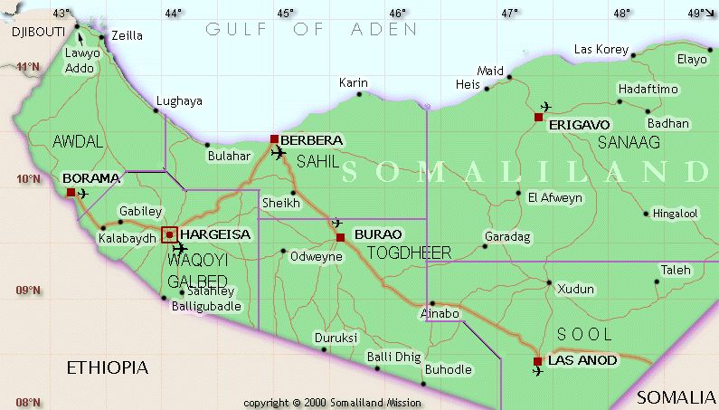

*****
Prague,January 2019

Feasibility study of the project
„Reconstruction of the cement plant in Berbera“

CONTENTS OF THIS FEASIBILITY STUDY

- The annotation
- The annotation project sheet
- About the project and the project rationale
- The market analysis and the Marketing concept
- The raw materiále inputs, the energy and the subsidiary material
- The placement of the project, the area of the cement plant and the enviromental impact
- The technical solution of the project
- The organization structure and a the overhead costs of the project
- Human resources
- The schedule of project realization
- The financial analysis and the requirement of the investment
- The economic analysis

ANEXXES

- Republic Somaliland in Africa - the map
- The placement of the cement plant in Berbera v Berbeře – the satelite image
- Area of the cement plant – the satelite image
- The current status of the cement plant

1. Annotation

In march 2008 was signed „the MEMORANDUM about cooperation“ between Czech-Somali´s chamber of the commerce and the company CZECH Engineering, s.r.o. The main reason for why the MEMORANDUM of the cooperation was found is creation the conditions for the company CZECH Engineering and other companies for the recontruction of the cement plant in BERBERA.
At the end of May and at the beginning of June, 2008 was realized the bussines trip to Somaliland, Berbera accordance with the MEMORANDUM of the cooperation and there was conducted the inspection of the cement plant to know the current status of the cement plant
The following documents was discussed and signed by relevant government authorities in accordance with the bussines trip:

  - The Licence Agreement about mining lime arround the cement plant Berbera
  - The Lease Contract of the area where is the cement plant (Berbera)
  - The Protocol on the use of labour in Rebulic Somaliland
  - The Cooperation Protocoll with the port in Berbera
  - The Protocol on profits derived from the operation of cement plant in favor of Republic Somaliland
  - The Protocol to ensure access to water for the operation of the cement plant

Based on the analysis and evaluation of available data has been compiled preliminary "feasibility study", whose conclusions are summarized in Section No.3.

In 2010, the company withdrew from the project Czech Engineering s.r.o. (the reason for this was the death of Mr. Ing. Zdeněk little man, who drove for the Czech Engineering Ltd. for the project) at the same time in 2009 the Czech Republic changed the name of the Somali Chamber of Commerce on the East African Joint Chamber of Commerce. Contract for the Czech Engineering Ltd. was taken over by NIKO TRADE Ltd. and its organizational folder in the Czech Republic NIKO TRADE CZ Ltd. at the end of 2013 and continues in the project further.

2. The annotation project sheet

The name of the project |  | Reconstruction of the cement plan in Berbera
Territory |  | Republic Somaliland
Goel/Object |  | Restoring operation of cement plant built in 1973 by Romanian society, which was in operation until 1991
The type of bussines |  | The „turn-key“ delivery
The contract party |  | BERBERA CEMENT, LTD.
General contractor |  | Not decided yet, coordination of training carrying out  NIKO TRADE LTD. and NIKO TRADE CZ LTD.
Subcontractors |  | - NIKO TRADE CZ LTD.  - Galaxtonez Limited s.r.o.  - PSP Přerov  - DITHERM, a.s.  - ZVVZ, a.s.  - Local bussines contractor of general contractor´s choice
Financing method |  | Project financing  It selected the optimal investor or a bank
The total price of supply |  | USD 50 000 000,-
The date | Presumption of tender |  | 10 - 11/2019
 | Presumption of contract closure |  | 12/2019
 | Delivery time |  | 09/2020 - 11/2022
Project Investigators |  | NIKO TRADE LTD. GALAXTONEZ LIMITED s.r.o.  Ing. Ivan Svoboda Jan Růžička  Jan Růžička

3 About the project and the project rationale

Cement plant at the port of Berbera built a Romanian company in 1973 to help Somalia with the MEAC. Cement plant was in operation until 1991 when it was badly damaged during the Civil War, when separating from the rest of Somalia, Somaliland, and proclaimed an independent republic of Somaliland.
Now, the cement plant is owned by the Republic of Somaliland and it is looking for potential investor. In this context, was approached by the Czech-East Africa Chamber of Commerce.

Main factors that represent strengths and weaknesses of the project, opportunities and threats are:

Strenghts | Weaknesses
- Clear Ownership  - The High quality basement of raw materials  - Location near the port of Berbera  - Possibility of relatively cheap energy inputs  - Practically no administrative restrictions | - The technical standard of the original equipment (in particular, before homogenization)  - Technical documentation of the original building construction is not exists
Opportunities | Threats
- The price of cement is very high and still increasing  - Possibility of constructing a new modern line without participation in the competition - procedure  - Presumption of a stable and peaceful political situation in accordance with the preparation of building a U.S. military next to Berbera | - The Republic of Somaliland is not internationally recognized  - Some possibility of terrorist attacks (very unlikely now, given the stability of the government of Somaliland)  - According to the OECD classification the Somaliland is 7th risk group and it is uninsurable country

4.The market analysis and the Marketing concept

The annual consumption of cement in the Republic of Somaliland is about 120 000 tonnes. Cement is imported through the port of Berbera and distributed by cars and trucks. The cement is packed always in bags of 50 kg.

The Republic of Somaliland, as in all other countries in the Horn of Africa, used dual pricing. The first price level is for distributors and wholesalers and the price for a 50 kg bag is between $ 6.00 and $ 8.00,ie 120-160 USD / t. The price is derived from the amount and according to available information, of 1000 Mt sells cement and larger and the price of 6.00 kg and USD/50 number around 100 Mt of cement for the price of $ 8.00 / 50 kg. Other price range depends on the quantity and detail price is around $ 9.00 to $ 10.00, ie 180-200 USD / t.

A relevant market for cement plant in Berbera is:

- The Republic of Somaliland
- Somalia
- Ethiopia
- Eritrea
- The Republic of Djibouti
- Southern Sudan
- Yemen
- Oman

To ensure the first phase distribution of cement from the cement plant will be used in Berbera by the network of distributors and at the same time the opportunities for the "memorandum about cooperation" agreement between the Czech-East Africa Chamber of Commerce and the Chamber of Commerce, Industry and Agriculture of the Republic of Somaliland.

For the founding of gradual market in East Africa will need to set up service centers, where the cement will be distributed to other areas of Central Africa. These distribution centers will be equipped with silos for storage of bulk cement storage and malts sacked cement.

In the first stage are 2-3 distribution centers in the Republic of Somaliland, 3 distribution centers in Somalia and 5 distribution centers in Ethiopia. In the implementation of distribution centers will help the Czech Embassy in Ethiopia.

If „the MEMORANDUM about cooperation“ with Sudan will be signed, so the distribution centers will be realized in Southern Sudan (at least two centers).

5.The raw materiále inputs, the energy and the subsidiary material

Basic raw material - limestone - is guaranteed by a license agreement on the extraction of limestone in cement plant near Berbera. Range of proven reserves are around 100 million tons of limestone. Place of extraction of raw material corrections will be clarified after a detailed analysis of 11/2019. Requirement of electricity will be ensured of refurbished diesel power units (5 x 1831kW).

Diesel fuel oil burned as a rotary kiln will be purchased at the oil terminal port of Berbera. Water supplies are secured "protocol to ensure access to water for the operation of cement plants“ directly from the main water supply of the cement plant. Refractories and spare parts will be imported through the port of Berbera.

6.The placement of the project, the area of the cement plant and the enviromental impact

The grounds of cement plant is situated 11km south from the port in Berbera, on the right from the road to Berbera – Burao, on the the mountain Sheikh. (For details see Annex No.1, No.2, No.3,).
The area is bounded by a cement concrete slab fence and is guarded by armed security guard.
During the inspection tour on May 28 - June 6, 2009 were in the area identified the following sites:

01. Bearing limestone
03. Crushing plant materials
03. Crushing limestone First Grade
03b. Crushing limestone Second Grade
03c. Crushing gypsum
09. Trays of raw materials
10. Grinding materials
11. Homogenization silos
14. Exchanger
15. Rotary kiln
16. Clinker Cooler
20. Fuel Economy
26. Transport and storage of cement
29. Cement mining
32. Transport and storage of cement
34. Packaging and shipping of cement
34a. Cement silos
34b. Filler cement
34d. Road weighing-machine
60. Substation 6kV
61. Measurement and management system
36. Compressor room
40. Laboratory
42. Mechanical Workshops
42a. Stock of materials
43. Energocenter
49. Furnace linings and lunge
80. Garage autopark
81. Office building
82. Changing rooms
83. Kitchen and dining room
84. Tank
85. Main water stop

The current status of the Cement plant is documented in Appendix No. 4.Environmental burden leaked from the lubrication circuit of cement raw mill (Building No. 29) and aboveground storage tanks (Building No. 20).

7.The technical solution of the project

Previously declared capacity of cement plant was 300,000 tons / year. Really it is achieved approximately 100,000 tons / year. The limiting factor is the particular performance tube mills 1.8 x 11.5 m (2 pieces of raw milling and grinding of 2 pieces of cement).

Technological risk can be attributed to a "prototype" solution homogenization of raw materials (see Annex 4, Fig.11).

The prime operation was faced with the consequences of poor homogenization of the raw materials.

THE CURRENT STATUS OF THE PROJECT:

- structure buidlings - are in generally good condition usable at low cost to repair the roof, wiring, windows, doors, air conditioning units, necessary equipment)

- mechanical part of a technological classification - all not used, need a complete overhaul, there is a risk of losing some smaller parts

c) electrical parts, including measurement and control - need to be replaced by a new installation of a new project

Following to the fact you can recommend technical - organizational solutions:

For the target capacity can be considered the production of cement 300 ton/year.

- All four tube mills 1.8 x11, 5 m to rebuild cement milling

- Pneumatic transport of raw meal and cement to replace the mechanical transport.

- To install a vertical grinding mill raw material corresponding performance

- Build a new homogenizing silo

- Recalculate the power heat exchanger and rotary kiln to propose appropriate modifications

- Increase storage sacked cement with manual palletizing

8.The organization structure and a the overhead costs of the project

To ensure the implementation of the project "Reconstruction of cement in Berbera“ and its next operation is proposed to establish a separate legal entity (eg, limited liability company) called BERBERA CEMENT, LTD.

It is expected that the company BERBERA CEMENT LTD, will have two separate organizational units:

- BERBERA CEMENT MANUFACTORING LTD who will be responsible for their own production of cement, and everything connected with the production of cement.

- BERBERA CEMENT DISTRIBUTION LTD who will be responsible for the complete distribution of cement across Africa and the Middle East.

Preliminary schedule of the supply system of the project is shown in Figure No.

As an exporter in the diagram given to this moment NIKO TRADE LTD. which now provides for the coordination of the project. It is assumed that the exporter (principal contractor) selects BERBERA CEMENT, LTD after its establishment.

BERBERA CEMENT, LTD. will be established with registered capital of 10.000 USD with this shareholder structure:
75% - a strategic investor
15% - the NIKO TRADE LTD. party represented by
10% - the Somaliland side.

The capital of the company BERBERA CEMENT, SE. will gradually increase to around 6-8 miles EUR..

Overhead costs of the project were estimated about CZK 7.5 million and will be covered by equity BERBERA CEMENT, LTD.
Preliminary schedule of the supply system project
Export insurance

3

Bank financing
6
2

5

1
BERBERA CEMENT, LTD
(importer)
NIKO TRADE LTD.
(exporter)

4

7
PSP Engineering

8
Galaxtonez Limited s.r.o.

9
PSP Přerov

10
ZVVZ

11
DITERM
PODZIMEK TŘEŠŤ

12

Czech East Africa Chamber of Commerce
13

Legenda:
1. Export Contract 9. Delivery of technologies
2. Credit agreement 10. Delivery dedusting
3. Contract of instance export credit risk 11. Supply and installation of linings
4. Delivery of goods and services 12. Supply and reconditioning of conveyor
5.Drawing buyer credit 13. Providing of materials, works and services
6. Repayment of loan
7. Delivery of technological part
8. Delivery of overhaul and assembly part

10. Human resources

Labor for restoration work and the actual operation of cement plant will be ensured on the basis of the "Protocol on the use of labor in the Republic of Somaliland

We expect by this manner to use around 230-250 local employees. Management of start-up reconstruction and stabilization operations will be provided under the supply contract with organizations using the potential strategic partners.

Costs of protective equipment and training are included in investment costs of the project.

11. The schedule of project realization

The implementation of the project is divided into three phases:

- phase - preparation 010-12/2019

Upcoming goals are:

- establishing a legal entity BERBERA CEMENT, LTD.
- selection of general contractor of reconstruction
- detailed analysis of raw materials
- clarification of technical terms for the development of the reconstruction project
- ensure the permanent presence of the representative BERBERA CEMENT,LTD.
has a cement plant
- preparing materials for the project funding to ensure its reconstruction
approval

II. phase - grinding and cement packing 09-12/2020

The aim of this stage is to produce all four tube mills cement from imported clinker and sell it as a package with a target capacity of 240 000t/rok.
- To reconstruct the associated operating and file the necessary equipment

III. phase - reconstruction of training materials and clinker burning 01/2021-
03/2022

The aim of this phase of reconstruction is to restore the ability to produce cement clinker.

12. The financial analysis and the requirement of the investment

Particular stages of the project were awarded on the basis of available evidence and expert estimate as follows:

I. phase - preparation 500.000,- USD
II. phase – grinding and cement packing 19.500.000,- USD
III. phase – linker burning 30.000.000,- USD

These investment costs include:
- Geological prospecting deposits of limestone 350.000,- USD
- Geodetic survey of the site 80.000,- USD
- Feasibility study 240.000,- USD
- Engineering project design 1.500.000,- USD
- Machinery 12.420.000,- USD
- Electro + Control systém 23.410.000,- USD
- Transport and instance 1.200.000,- USD
- Assembly 4.800.000,- USD
- Construction 3.200.000.- USD
- Technical support 2.500.000,- USD
- Training of workers 3.000.000,- USD
Total cost: 50.000.000,- USD
13. Economic analysis of the project

There were developed two variants of an integrated financial analysis project (see Table 1 and Table 2, which works with the following input parameters:

Parameter | Blue option | Optimistic option
a) The selling price of cement | 120 USD/t | - D/t
b) Revenues from sales of cement per year | 28.600.000,- USD | 38.400.000,-USD
c) Interests + credit insurance | 7% p.a. | 7% p.a.
d) Depreciation | 8 let | 8 let
e) Costs of cement production from imported clinker | 80 USD/t | 80 USD/t
f) Costs of cement production from own clinker | 60 USD/t | 60 USD/t

INTEGRATED FINANCIAL ANALYSIS OF PROJECT
„RECONTRUCTION OF THE CEMENT PLANT IN BERBERA“
(optmistic option)
tis. USD
 |  | Preparation | Recontruction
 |  |  | I. phase | II.phase
 |  | 2019 | 2020 | 2021 | 2022 | 2023 | 2024 | 2025 | 2026 | 2027 | 2028 | 2029
1 | Total costs | 500 | 19 500 | 30 000
2 | Operating costs |  |  | 22 890 | 23 625 | 22 882 | 22 138 | 21 394 | 20 650 | 20 650 | 20 650 | 18 150
 | 2.1 Cash expenses |  |  | 19200 | 14400 | 14400 | 14400 | 14400 | 14400 | 14400 | 14400 | 14400
 | 2.2 Depreciation |  |  | 2 500 | 6 250 | 6 250 | 6 250 | 6 250 | 6 250 | 6 250 | 6 250 | 3 750
 | 2.3 Interests for the loan repayment |  |  | 1 190 | 2 975 | 2 232 | 1 488 | 744
3 | Returns |  |  | 38 400 | 38 400 | 38 400 | 38 400 | 38 400 | 38 400 | 38 400 | 38 400 | 38 400
 | 3.1 Revenues from sales |  |  | 27 600 | 27 600 | 27 600 | 27 600 | 27 600 | 27 600 | 27 600 | 27 600 | 27 600
4 | Net cash income |  |  | 15 510 | 14 775 | 15 518 | 16 262 | 17 006 | 17 750 | 17 750 | 17 750 | 20 250
 | 4.1 Income tax |  |  | 0 | 0 | 0 | 0 | 0 | 1 775 | 1 775 | 1 775 | 2 025
 | 4.2 Net profit |  |  | 15 510 | 14 775 | 15 518 | 16 262 | 17 006 | 15 975 | 15 975 | 15 975 | 18 225
 | Interests |  |  | 1 190 | 2 975 | 2 232 | 1 488 | 744 | 0 | 0 | 0 | 0
 | 4.3 Net profit + interests |  |  | 16 700 | 17 750 | 17 750 | 17 750 | 17 750 | 15 975 | 15 975 | 15 975 | 18 225
 | Depreciation |  |  | 2 500 | 6 250 | 6 250 | 6 250 | 6 250 | 6 250 | 6 250 | 6 250 | 3 750
 | 4.4 Net profit + interests + depreciaton |  |  | 19 200 | 24 000 | 24 000 | 24 000 | 24 000 | 22 225 | 22 225 | 22 225 | 21 975
5 | Net cash flow |  |  | 19 200 | 24 000 | 24 000 | 24 000 | 24 000 | 22 225 | 22 225 | 22 225 | 21 975
6 | Funding sources | 500 | 19 500 | 30 000
 | 6.1 Share capital | 500 | 2 500 | 4 500
 | 6.2 Bank loan |  | 17 000 | 25 500
7 | Financial liabilities |  |  | 1 190 | 13 600 | 12 857 | 12 113 | 11 369 | 0 | 0 | 0 | 0
 | 7.1 Repayment of the loan |  |  |  | 10 625 | 10 625 | 10 625 | 10 625
 | 7.2 Interests for the loan repayment |  |  | 1 190 | 2 975 | 2 232 | 1 488 | 744 | 0 | 0 | 0 | 0
 | 7.3 Dividends
8 | Net cash balance |  |  | 18 010 | 10 400 | 11 143 | 11 887 | 12 631 | 22 225 | 22 225 | 22 225 | 21 975
9 | Cumulative net cash balance |  |  | 18 010 | 28 410 | 39 553 | 51 440 | 64 071 | 86 296 | 108 521 | 130 746 | 152 721

INTEGRATED FINANCIAL ANALYSIS OF PROJECT
„RECONTRUCTION OF THE CEMENT PLANT IN BERBERA“
(blue option)
tis. USD
 |  | Preparation | Recontruction
 |  |  | I. phase | II.phase
 |  | 2019 | 2020 | 2021 | 2022 | 2023 | 2024 | 2025 | 2026 | 2027 | 2028 | 2029
1 | Total costs | 500 | 19 500 | 30 000
2 | Operating costs |  |  | 22 890 | 23 625 | 22 882 | 22 138 | 21 394 | 20 650 | 20 650 | 20 650 | 18 150
 | 2.1 Cash expenses |  |  | 19200 | 14400 | 14400 | 14400 | 14400 | 14400 | 14400 | 14400 | 14400
 | 2.2 Depreciation |  |  | 2 500 | 6 250 | 6 250 | 6 250 | 6 250 | 6 250 | 6 250 | 6 250 | 3 750
 | 2.3 Interests for the loan repayment |  |  | 1 190 | 2 975 | 2 232 | 1 488 | 744
3 | Returns |  |  | 28 800 | 28 800 | 28 800 | 28 800 | 28 800 | 28 800 | 28 800 | 28 800 | 28 800
 | 3.1 Revenues from sales |  |  | 27 600 | 27 600 | 27 600 | 27 600 | 27 600 | 27 600 | 27 600 | 27 600 | 27 600
4 | Net cash income |  |  | 5 910 | 5 175 | 5 918 | 6 662 | 7 406 | 8 150 | 8 150 | 8 150 | 10 650
 | 4.1 Income tax |  |  | 0 | 0 | 0 | 0 | 0 | 815 | 815 | 815 | 1 065
 | 4.2 Net profit |  |  | 5 910 | 5 175 | 5 918 | 6 662 | 7 406 | 7 335 | 7 335 | 7 335 | 9 585
 | Depreciation |  |  | 1 190 | 2 975 | 2 232 | 1 488 | 744 | 0 | 0 | 0 | 0
 | 4.3 Net profit + interests |  |  | 7 100 | 8 150 | 8 150 | 8 150 | 8 150 | 7 335 | 7 335 | 7 335 | 9 585
 | Depreciation |  |  | 2 500 | 6 250 | 6 250 | 6 250 | 6 250 | 6 250 | 6 250 | 6 250 | 3 750
 | 4.4 Net profit + interests + depreciation |  |  | 9 600 | 14 400 | 14 400 | 14 400 | 14 400 | 13 585 | 13 585 | 13 585 | 13 335
5 | Net cash flow |  |  | 9 600 | 14 400 | 14 400 | 14 400 | 14 400 | 13 585 | 13 585 | 13 585 | 13 335
6 | Funding sources | 500 | 19 500 | 30 000
 | 6.1 Share capital | 500 | 2 500 | 4 500
 | 6.2 Bank loan |  | 17 000 | 25 500
7 | Financial liabilities |  |  | 1 190 | 13 600 | 12 857 | 12 113 | 11 369 | 0 | 0 | 0 | 0
 | 7.1 Repayment of the loan |  |  |  | 10 625 | 10 625 | 10 625 | 10 625
 | 7.2 Interests for the loan repayment |  |  | 1 190 | 2 975 | 2 232 | 1 488 | 744 | 0 | 0 | 0 | 0
 | 7.3 Dividends
8 | Net cash balance |  |  | 8 410 | 800 | 1 543 | 2 287 | 3 031 | 13 585 | 13 585 | 13 585 | 13 335
9 | Cumulative net cash balance |  |  | 8 410 | 9 210 | 10 753 | 13 040 | 16 071 | 29 656 | 43 241 | 56 826 | 70 161

The Republic of Somaliland in Africa

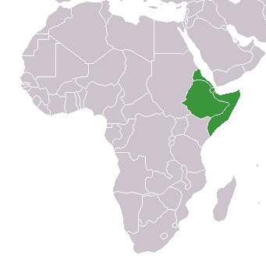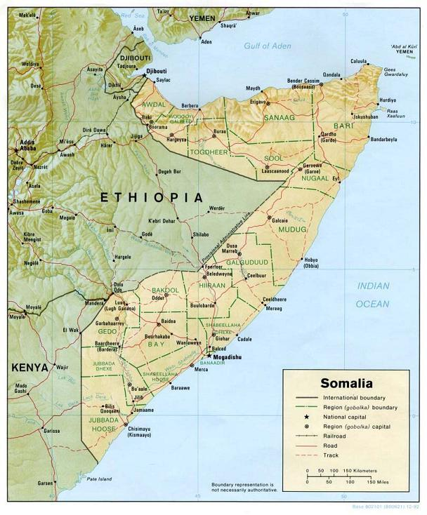

Localization of cement plant in Berbera – satelite picture

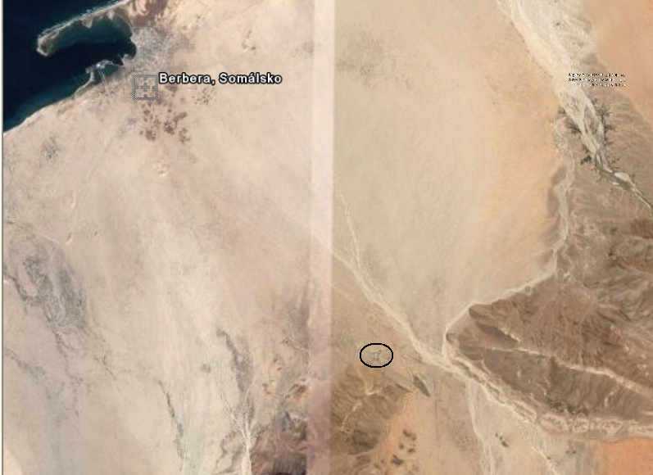

Location of cement plant – satelite picture

