

**Energetics for Somaliland**

## Project of construction of combined power sources

## Feasibility study

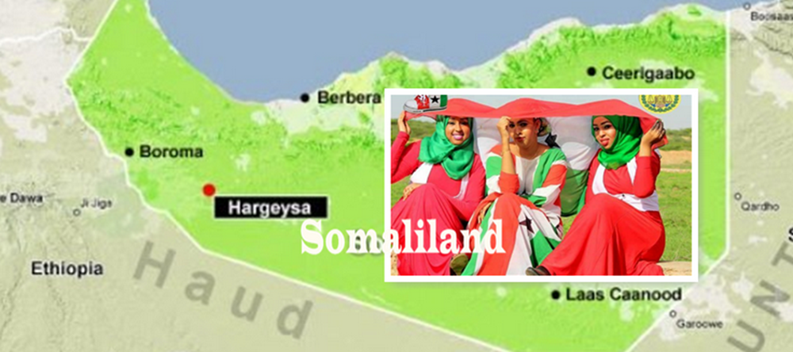

1. Annotation

Somaliland is a young, dynamically developing country. To grow in industry, construction and agriculture many times it needs more electricity than it currently has.

The East African region in terms of access to elektricity, is statistically rated as the region with the highest population without access to electricity. The available service is unreliable and expensive. This is mainly provided from low-efficiency diesel generators, which are a source of air polluting emissions and their operation is expensive, thus unavailable to the majority of the population. The output of these aggregates is limited, insufficient and practically unusable for larger customers (eg cement works), which hinders the development of industry.

East Africa has very favorable conditions for using solar energy as well as for obtaining energy from wind power farms. Somaliland has great potential for generating electricity in an environmentally emission-free manner. It has all the preconditions to build a stable and strong energy network, that will help the rapid growth of all sectors of industry and life. Thanks to the disproportionately lower price of electricity from these sources, it will allow access to its sources for a much wider population.

The energy sector cannot be seen as a separate project; the construction of electricity sources will subsequently develop construction, industry, transport infrastructure (electrification of the planned railway). There will be better conditions for efficient mining and use of mineral resources that do not harm the environment.

Thanks to technical progress and technology development, we can build energy that has the most advanced parameters of a strong and stable, fully managed, regulated network from environmentally friendly sources, flexibly adapting to the growth of demand and the needs of the country.

This study describes the feasibility of such a project, its intent, technical implementation and economic aspects.

2. Project summary sheet

|  |  |
| --- | --- |
| Name of Project | Project of construction of combined energy sources in Republic of Somaliland |
| Teritory | East Africa – Republic of Somaliland |
| Target / Intention | Selection of sites for construction of wind and solar power plants, determination of output for given regions. Construction of power plants, energy storage and regional network. Sale of elektricity. |
| Type of trade | Turnkey contract |
| Contractor | Czech-East African Chamber of Commerce |
| Main contractor and coordinator | NiKO Trade Ltd.  NiKO Trade CZ Ltd.o.z. |
| Subcontractors | - **Capital and investment company**.. project financing (partner bank Oman – not published)  - **Galaxtonez Limited s.r.o**. ... supplier of technologies, technique, logistics, material provision  - **NiKO Trade CZ Ltd.** ... project activities, human resources  - Company producing and selling electricity (to be established)  - Company managing distribution networks and distribution (to be established |
| Method of financing | Project financing   1. From own resources   - project preparation  - securing contracts  2) Capital and investment company  - financing of technique purchase and purchase of technologies  - construction of power plants and energy storage facilities  - building of distribution networks |

3.SWOT analysis

**Project strength –**

**- Gouvernment´s interest in building an energy system**

**- developing a country in need of electrical energy**

**- project realization directly related to the development of earth electrification**

**- clear ownership relations**

**- strategic location in East Africa**

**- no administrative restrictions**

**Weaknesses –**

**- not existing distribution network**

**- lack of qualified staff**

**- language barrier on the part of local people**

**Opportunities –**

**- the possibility of building a 100% green energy network**

**- lack of electricity, low quality and stability of supply**

**- development assumption and increasing demand**

**- stable political situation, democratic society**

**- improvment of environmental polici, solutions to eliminate emmissions**

**Risks –**

**- industrial backwardness**

**- necessity of importing all the techniques**

**- according to the OECD classification, East Africa is in the 7th risk group**

**- project is difficult to insure**

4. Project intent presentation

This project consists of the construction of wind power plants complemented by solar parks. This hybrid system will always be complemented by storage technology, which accumulates the generated electricity, which it regulates, controls consumption. Thus, it manages the immediate need for increased consumption, reduces negative processes and prevents power outages. This system guarantees the production of electrical energy of high parameters for the most demanding requirements, guarantees a long service life and low operating and service costs.

The placement will be divided into all 14 administrative units according to the approved parameters, according to the number of inhabitants, population density and planned requirements to cover the power input. This strategy will be solved it detail with representatives of administrative units and the Ministry.

**Picture No.: 1**

**Wind turbines will be complemented by solar power plants and will create hybrid sources of power generation that take andvantage of each system.**

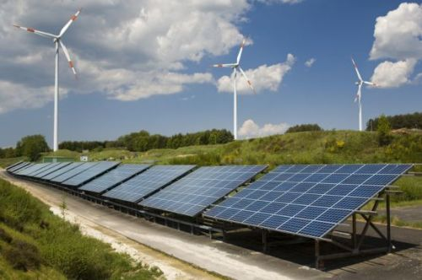

**Picture No.: 2**

**These hybrid wind and solar power systems will be complemented by an innovative, modular SIESTRAGE pover storage system.**

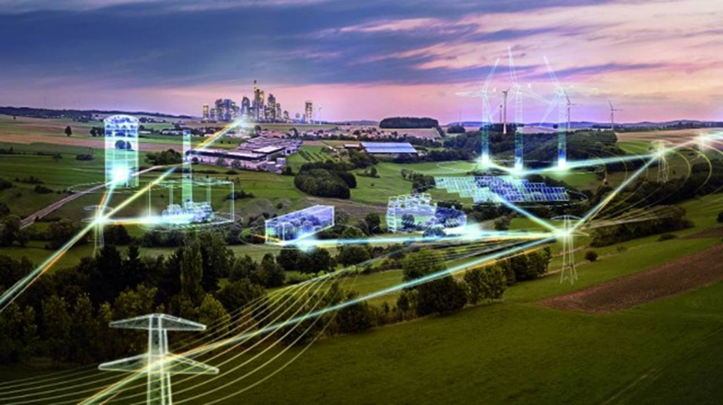

The construction of these separate units will allow all areas to have access to electricity in the required capacity, always with a planned reserve for higher energy consumption requirements due to development in the area. Individual regions will have unlimited access to electricity without the need to build a nationwide central distribution network and will be regionally managed according to the current requirements of each area. The central distribution network will be built together in the construction of transport infrastructure (railways, roads, motorways). After all the individual regional networks will be integrated into a central distribution network, which will bring absolute control over the production and consumption of electricity with the bac-kup use, regulation and certainly the possibility of selling overproduced energy to neighboring states. This project will bring Somaliland full electrification, energy independence and a permanent source of income.

5. Technical solution of the project

**Wind power plant -**

Wind turbine of SL1500=>1,5MW series is the third generation of advanced and reliable power generation technology.

Diameters of used rotors 70/77/82/90 / 93m and tube heights 65/70/80 and 100m, which meets the special requirements of coast areas.

This range of wind turbines obtained GL, TüV, SüD and CGC certificates.

Over 8000 turbines of this type are in service worldwide.

Wind turbine of SL2000=>2.0MW series is an optimized technology with reliable operation and easy maintenance. The intelligent control system delivers optimum operating conditions and maximum service life.

Rotor diameters of 100/110/116 /121m and tube height of 80/90/100m are particularly useful for TCII areas and zones with lower wind speeds.

This range is ideal for coast, mountain and high mountain areas. The SL2000 / 116 and 121 wind turbines are optimal for low-speed zones.

Wind turbine of SL3000=>3.0MW series is a second generation turbine with this power. It excels in advanced and reliable technology. Its exceptional resistance and increased protection against the corrosive effects of sea salt, make it suitable for both coastal and tidal areas, as well as for land use

The series has passed GL and CGC certification, the most demanding safety and reliability tests. It is a compact drive train with highly efficient and reliable technology, ideally distributed loads, offshore maintenance technology for large individual units – it all reduce operating and service costs.

**Solar power stations –**

Model : SP 1MW

Specification : Normal

Aplication : Commercial

Output voltage : 220V

Working time : daylight exposure

Type of solar panel: Monocrystalline silicon

Battery type: Lead Acid

Maximum input voltage : 1000V

Panel type : 250W

Monopanel, efficiency 22%

New inverter design

Inverter with built-in MPP5 controller

Parts of system delivery : control pane+changer+battery+condenser

Warranty : 25 years

Free replacement of damaged parts during warranty.

**Modular electrical energy storage system -**  SIESTORAGE –Siemens Technology – the modular battery system (Siemens Energy Storage) optimizes the subjects connected to the mains. It compensates for the negative impact of renewable energy sources at critical points of the network - regulates active and reactive power exactly according to current requirements.

It provides network stability, is modular, uses Li-ion batteries and power electronics.

Three main parts : - battery box

- control system

- power connection

The accumulated power is supplied via the AC / DC converter directly to the low voltage grid or via a transformer to the MV grid. The range for accumulation and power control is from 280kW to 16MW.

The modular container design minimizes assembly costs and facilitates transportation to the destination.

**Picture No.:3**

**Unit of SIESTORAGE modular system**

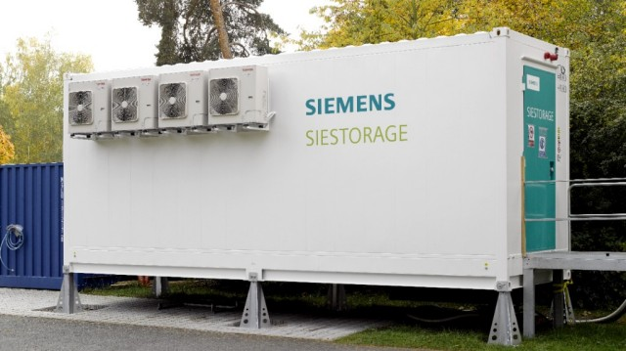These systems, which offer absolutely reliable and stable energy production, are fully controllable, can be supplemented with a variety of equipment in the fields of cooling, heating, heating of operating fluids, etc.

For specific conditions and customer requirements, these systems can be complemented by **tri-hybrid technology H.S.T.S**, which is an original solution for sampling points with variable wind speed, short time of sunlight. This solution is patented by our supplier company **Galaxtonez Limited s.r.o.**

6. Project localization

**Picture No.: 4**

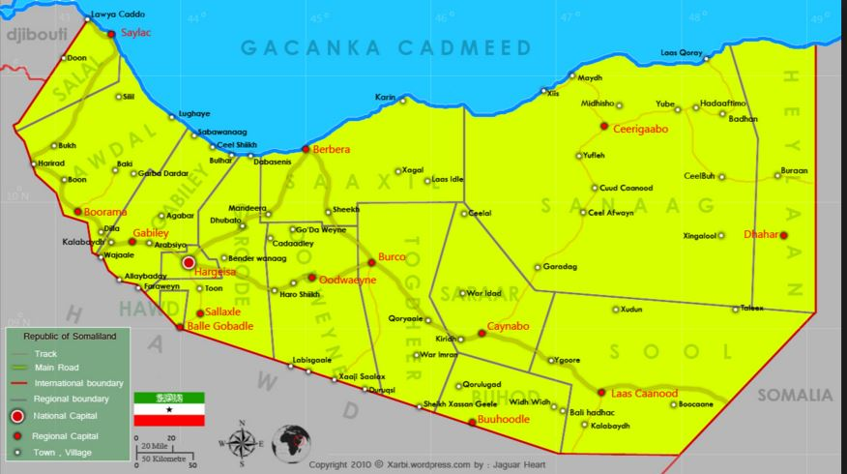

On the map of Picture No.: 4 we see the legal division of the Republic of Somaliland into 14 legal entities:

* **SALAL** the administrative city **Saylac** (approx. 25,000 inhabitants) is located on the border with Djibouti; the area is relatively underpopulated and in total there live about 100,000 residents. There is a transit road to Djibouti. Contemplated construction: 3 power parks with total output ..**.18MW**

**Picture No.:5: Beautiful coast near Saylac**

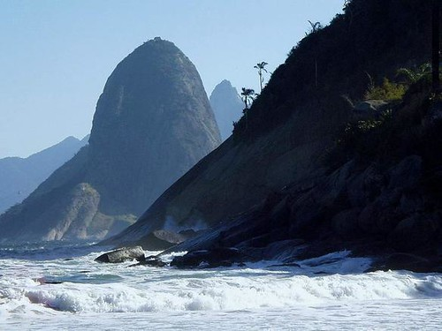

* **AWDAL** the administrative city **Boorama** (over 215,000 inhabitants), the agricultural area, mainly pastoralism, fishing and trade, cross-border trade with Ethiopia. The total of about673,000 inhabitants in this area. Contemplated contstruction: 3 power parks with a total output of ..**45MW**

**Picture No.:6 : Boorama**

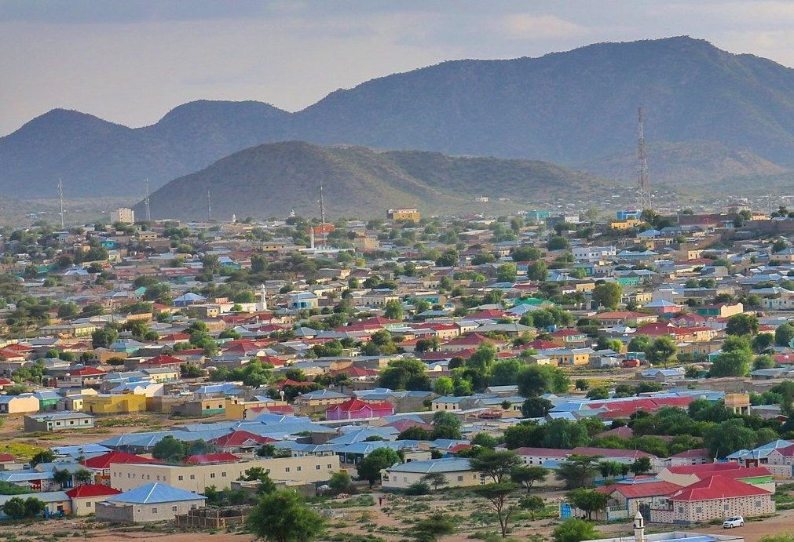

* **GABILEY** the administrative city **Gabiley**(over 100,000 residents), an important area of agriculture, 85% of food comes from this area. Focusing on growing crops, vegetables and fruit. Total of inhabitant lived in this area is about 320,000.Contemplated contstruction: 4 power parks with a total output of...**38MW**

**Picture No.:7 : Farmer near Gabiley**

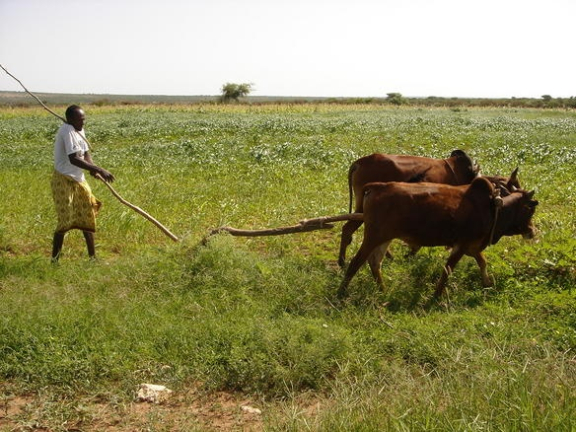

* **HAWD** the administrative city **Balle Gobadle,** smaller area on border with Etiopia, camel, goat and sheep breeders. Estimated population: 50,000.   
  Total considered installed power...**9MW**
* **GAROODE** the administrative city of **Sallaxle**, the area crosses the main road between Hargeysa and Berbera. The area around this road is very densely populated by more than 300,000 inhabitants. The premis is to build 4 energy parks with a total output of ..**50MW**
* **MARRODI JEEX** the administrative city of **Hargeisa** (capital of Somaliland approximately 760,000 citizens), region dynamically developing, large construction, international airport. Total population is about 1.5 mil of people. The premis is to build 4 energy parks with a total output of ..**150MW**

**Pictures No.:8,9: International airport in Hargeise, hotel Maansoor**

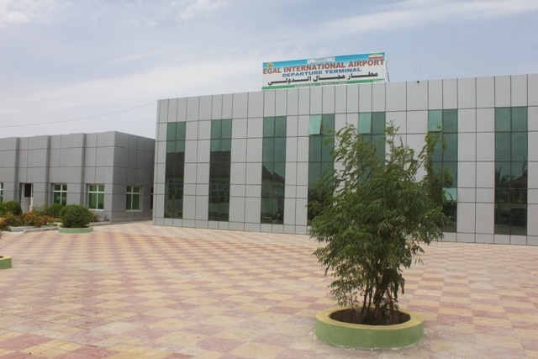

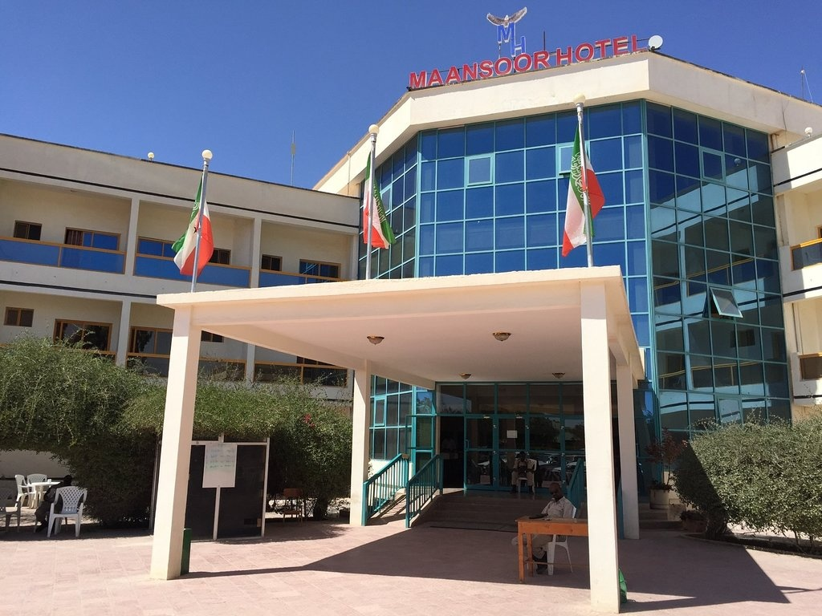

* **SAAXIL (SAHIL)** the administrative city **Berbera** (aprox. 250.000 inhabitants). Very important area for the development of the entire „Horn of Africa“, thanks to the port, which after reconstruction by DP World will become an important transport hub for all East Africa. Expected growth of industry (Berbera cement factory), airports, railways and others, need a strong energy background. The area has total population of about 360,000 and there is the assumption of a strong inflow of population. The premis is to build 4 energy parks with a total output of..**115MW**

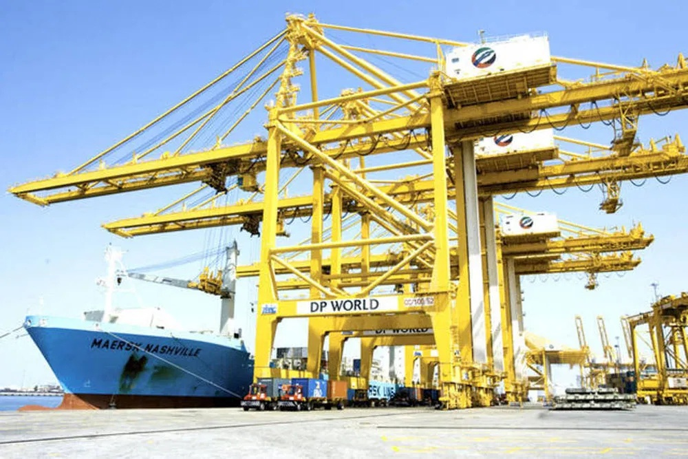

* **OODWEYNE** the administrative city **Oodweyne** (over 190,000 inhabitants), a large area inte center of the country. The total of about 250,000 inhabitants live in the area. Considered separate smaller energy units, divided by towns and villages in the area by total power .**.35MW**
* **TOGDHEER** the administrative city **Burao** (appr. 350,000 inhabitants), an emerging industry area. The premis is to build 3 energy parks with total output ..**125MW**

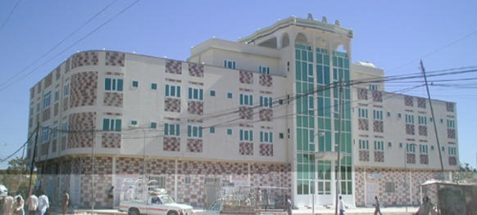

* **SARAAR** the administrative city **Caynabo**, smaller area on gypsum plains. Expected growth of industry in mining, agriculture, pastoralism. Total of population is over 100,000, the wast majority live in the region of the city. Expected construction of two energy parks with total output .. 20MW
* **SANAAG** the administrative city **Ceerigaabo** (Erigavo over 114tis.obyvatel), the area with the greatest unfavorable condition of forst loss (52%) and soil erosion. Necessity of economic recovery for regional development. Thanks to the foothill environment and long coast there is the possibility of tourism development and other activities, simultaneously breeding animals. Total population of about 250.000 inhabitants. Contemplated construction of multiple parks according to the location of towns and villages with total power ..**75MW**

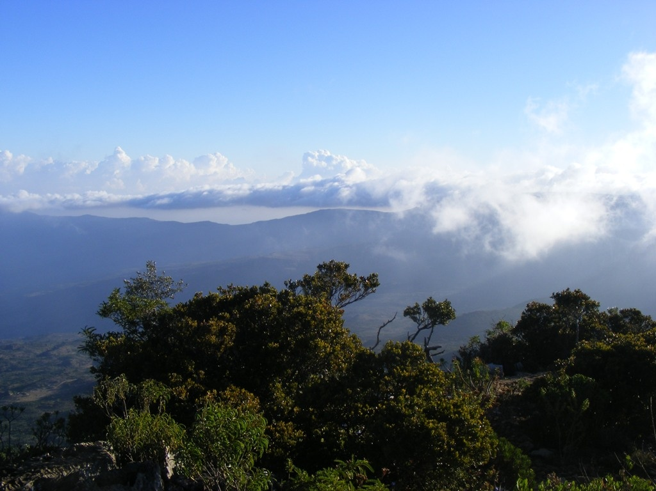

* **BUHOD** the administrative city **Buudoodle**, smaller administrative area with about 50,000 inhabitants. The intention is to build energy sources with total output...**10MW**
* **HEYLAAN** the administrative city **Dhahar**, the area is adjacent to the border with Putland. Population of about 60,000 inhabitants. The intention is to build energy sources with total output ..**15MW**
* **SOOL** the administrative city **Laas Caanood** (Las Anod 75,000 inhabitants) High tax revenues (40%) are provided by telecommunications and financial services of resident banks. The region is dominated by v regionu převažuje pastoralism and livestock breeding. Expected rapid development of the region thanks to verified natural gas field. Předpokládaný rychlý rozvoj regionu díky ověřenému nalezišti zemního plynu, Future large indurstrial area. Total population over 325,000 inhabitants. Estimated installed power ..**43MW**

 The Republic of Somaliland has tremendous growth potential and needs high-quality and stable energy sources. Its location and morphology of the area is predestined for the construction of ecological energy units using wind and solar energy

.

7. Market analysis and marketing concept

Current electricity consumption is increasing in Somaliland, but demand exceeds supply, with resources being very limited, unstable and expensive to produce, polluting the environment with emissions and noise. The survey showed that the costs per 1kWh are different according to regions and suppliers and range from 0,8 až do 1,2 USD/kWh!!

Providing cheap and affordable electricity from stable sources is a prerequisite for the country's economic growth. Thanks to the chosen technology for the production of electric energy, energy costs will be reduced rapidly, while the environmental burden on the landscape will be reduced.

Most of the country's population lives in urban or suburban agglomerations. At present, production of elektricity covers only around 20% of demand.

Our project in its first phase of electrification of the country plans to output 750MW, that is at a standard efficiency of renewable power plants 40%, real 300MW intended for consumption, according to research it will cover 70% of the demand for electricity supply.

The feasibility of sampling and purchasing strenght can be determined by simple analysis :

The number of inhabitants that will appeal to the offer.............................. 2,000.000

Real power of energy units………………........................................................... 300.000kW

Daily consumption, thatś in 24 hours............................................................ 7,000.000kW

Estimated starting prica fo kWh…………………. ............................................... 0,30USD/kWh

Daily consumption in USD............................................................................. 2,100.000,00 USD

Cost of electricity per one person is in the amount of……........................... 1,05USD

Monthy cost of electricity consumption per one person……………………........ 31,50USD

Given the average monthly family earnings in the city, which is over $ 200, the energy costs are acceptable and, in addition, will decrease in proportion to the return on investment up to the planned amount of costs per 1kWh not exceeding 0.20USD. The largest customers will be current and future industrial and business entities, so the calculated consumption is absolutely real. Enough electricity also helps to reduce the production and consumption of charcoal, which devastates forests and pollutes the air.

The advantage of this project is, among other things, that it is a modular solution and so it is possible to respond flexibly to the increase in demand in one or another region. Thus, it enables conceptual planning of development and is able to respond to customer needs in the future.

8. Organizational structure and overhead costs

In order to ensure the implementation of the project “Energy for Somaliland” - Project of construction of combined sources of electric energy and subsequent operation of energy parks - it is proposed to establish an independent economic unit (eg joint stock companies) with joint participation of stakeholders. This company will be established during the preparation of implementation.

The percentage ratio scheme in the company will be the subject of negotiations between the investor, the contractor, the main contractor and the representation of the Republic of Somaliland.

The initial stake for the investor will be ..................... 85%

Contractor and Main contractor ................................. 10%

Representation of the Republic of Somaliland ............. 5%

After the project is put into operation, the company will take over all buildings and equipment, distribution networks and accessories. Already during the realization after the start of the individual units, the investor's investment capital will be gradually repaid on the basis of revenues from the supplied electricity, which will also reduce the investor's share in the company in proportion.

Upon full repayment of the invested amount, at the General Meeting the capital breakdown of the Company shall be adjusted by decision:

Investor .................................................................. 45%

Contractor and Main contractor ……………………….... 45%

Representation of the Republic of Somaliland ........10%

During construction, a system of investor´s financial flows will be established on the basis of approved protocols for the purpose of financing individual stages of implementation. All invoicing will be carried out through NiKO Trade Ltd., with the consent of the investor, who will have a regular overview of the use of funds.

The investor has the right to decide, after the whole project has been put into full operation, whether to remain as a shareholder of the incorporated company or, with the consent of the other shareholders, to sell its shares to another entity.

The name of the company will be consulted before its establishment; after fulfilling all legal requirements for the establishment of the company, bank accounts will be opened at the recommended bank.

9. Human Resources

The necessary number of workers who become employees of the joint-stock company, will be selected for the construction of power plants in individual locations. This company will pay all legal fees for the employees. At present, there is high unemployment in the Republic of Somaliland, as in the whole of Africa. As a result, it will not be a problem for the construction of power plants to provide the necessary workforce. They will be properly trained and familiarized with all safety regulations for professional work. This will also increase their skills and improve their position in the labor market.

A sagnificant part of these workers will remain in employment to ensure the maintenance and operation of the power plants.

The intention is to cooperate with educational establishments throughout Somaliland on training of technical personnel for the field of production and distribution of electricity, for electromechanics of distribution equipment, operating electricians and other related fields.

10. Project schedule

1. Preparation of the whole project, project documentation, tenders ...... 1/2020
2. Negotiations with the investor and all stakeholders……………................. 1,2/2020
3. Start of production of components,   
   logistics, preparation for construction ................................................... 3/2020
4. Start of assembly and commisssioning…..................................... 4/2020-12/2022
5. Completion of the first phase of the project............................................. 1/2023
6. The preparation of the whole project does not include only the choice of technology, logistics planning, selection of suppliers ... it is above all a thorough reconnaissance of locations, according to the agreement and specification of installed outputs in individual regions, meteorological measurements of wind speed and direction by using the VAS method. The WAsP method creates a model of flow in the ground layer of the atmosphere.

For this purpose, measurements at synoptic and climatological stations located in selected locations of the considered sites will be used, taking into account orographic data.

In these locations, a detailed measurement will be carried out to evaluate the efficiency of the solar PV panels used. The current exposure value (W / m2) is measured.

In these locations a detailed measurement will be carried out to evaluate the efficiency of the solar panes of photovoltaic power plant. The actual exposure value (W/ m2) is measuret.

The measurement will evaluace not only the exposure time, but also the intensity of glare, the angle of incidence of solar radiation, and the extent of scattering.

The data will be collected on-line, where all the information collected will be documented and will be used to select the right technique, adjusting the parameters to ideally set the technology for maximum efficiency and stability. The conclusions of the evaluation of these data will be discussed with the representatives of the regions, to select the best solution to meet the requirements of electricity consumption for the given location, while maintaining maximum efficiency.

1. Contract negotiations with the investor have been taking place since 5/2019 according to his requirements, the projects were modified and subsequently negotiations with representatives of the Republic of Somaliland were started.

After a very helpful attitude and 100% support for projects by the representative of the Republic of Somaliland, when important documents leading to the possibility of realization of the presented projects were signed, the negotiations with the investor are resumed, where the technical support and procedures for financing these projects are addressed.

1. 3) Instruction for commencement of purchase of power plant components and accession to power plant logistics planning, construction preparations will be issued immediately after approval of project implementation and release of funds by the investor
2. According to the construction and commissioning schedule
3. According to the schedule

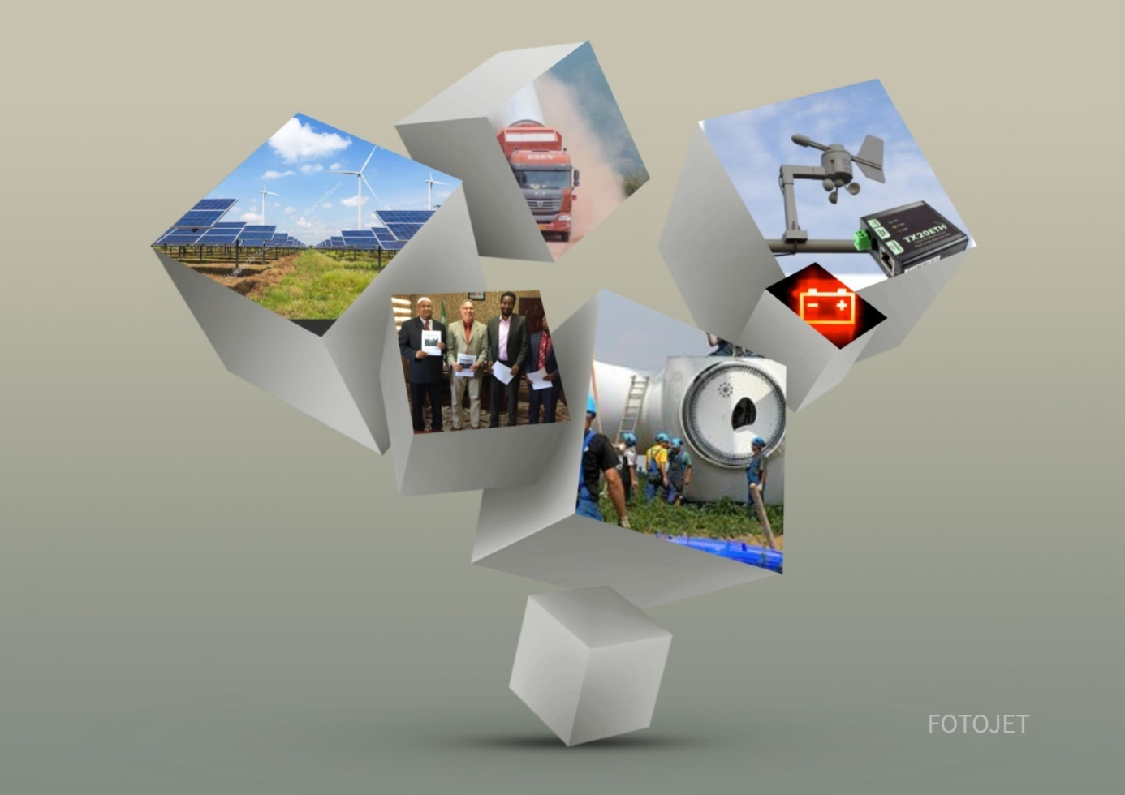

11. Economic analysis of the project

**LAYOUT OF ENERGY PARK CONSTRUCTION**

|  |  |  |
| --- | --- | --- |
| REGION | Number of Energy parks | Expected MWh consuption |
| SALAL | 3 | 7 |
| AWDAL | 5 | 18 |
| GABILEY | 4 | 15 |
| HAWD | 3 | 3 |
| GAROODE | 4 | 20 |
| MARRODI JEEX (Hargeisa) | 4 | 60 |
| SAAXIL(SAHIL) | 3 | 45 |
| OODWEYNE | 4 | 14 |
| TOGDHEER | 3 | 50 |
| SANAAG | 10 | 30 |
| SARRAR | 2 | 7 |
| BUHOD | 2 | 4 |
| HEYLAAN | 2 | 7 |
| SOOL | 2 | 18 |
| In total | 51 | 298 |

Estimated installed power **750MW -**  real average power **300MW** (40% efficiency)

**BREAKDOWN OF TECHNOLOGY SETS OF INDIVIDUAL PARK**

|  |  |  |  |  |  |  |
| --- | --- | --- | --- | --- | --- | --- |
| REGION | ENERGY  PARKS | WIND TURBINES | SOLAR  POWER | ENERGY  STORAGE | SAMPLING PLAN | INST.  POWER |
| SALAL | 3 | 9x1,5MW | 9x0,5MW | 3x3MW | 7MW | 18MW |
| AWDAL | 5 | 15x2MW | 15x1MW | 5x4MW | 18MW | 45MW |
| GABILEY | 4 | 12x3MW | 12x1MW | 4x4MW | 15MW | 36MW |
| HAWD | 3 | 3x2MW | 3x1MW | 3x1MW | 3MW | 9MW |
| GAROODE | 4 | 12x3MW | 4x2,5MW | 4x5MW | 20MW | 50MW |
| MARRODI  JEEX | 4 | 36x3MW  16x2MW | 24x2MW  4x0,5MW | 4x15MW | 60MW | 150MW |
| SAAXIL  (SAHIL) | 3 | 33x3MW  3x2MW | 12x3MW  3x0,5MW | 3x15MW | 45MW | 112MW |
| OODWEYN. | 4 | 12x2MW | 9x1MW | 4x4MW | 14MW | 36MW |
| TOGDHEER | 3 | 24x3MW  6x2MW | 21x2MW | 3x16MW | 50MW | 126MW |
| SANAAG | 10 | 10x3MW  10x2MW | 10x2,5  MW | 10x3MW | 30MW | 75MW |
| SARAAR | 2 | 4x1,5MW | 6x1,5MW | 2x4MW | 7MW | 18MW |
| BUHOD | 2 | 4x2MW | 4x1MW | 2x2MW | 4MW | 12MW |
| HEYLAAN | 2 | 4x1,5MW | 6x1,5M | 2x4MW | 7MW | 18MW |
| SOOL | 2 | 10x3MW | 6x2,5MW | 2x9MW | 18MW | 45MW |
| TOTAL | | | | | <300MW | 750MW |

**SUMMARY ANALYSIS OF PROCUREMENT PRICE OF TECHNOLOGY**

|  |  |  |  |
| --- | --- | --- | --- |
| Technology | Pieces | Price per piece/MW | Total USD |
| SL1500-1,5MW | 17 | 1,100.000USD | 18,700.000 |
| SL2000-2,0MW | 69 | 1,500.000USD | 103,500.000 |
| SL3000-3,0MW | 137 | 2,300.000USD | 315,100.000 |
| Solar SP/1MW | 245 | 410.640USD | 100,606.800 |
| SIESTORAGE/1MW | 305 | 551.520USD | 168,213.600 |

Total 713,470.400USD

**CONSTRUCTION, TRANSPORT AND TECHNICAL ASSURANCE COSTS**

|  |  |  |  |  |
| --- | --- | --- | --- | --- |
| Technology,  Support means | Transport | *Construction | Operating costs | **Other costs |
| Solar power plant | 7,350.000USD | 2,450.000USD | - | 350.000USD |
| Wind power plant | 61,775.000USD | 26,037.703USD | - | 460.000USD |
| Siestorage | 6,500.000USD | 2,250.000USD | - | 250.000USD |
| Technics | 750.000USD | - | 50.000USD | 1,105.000USD |
| Human resources | 25.000USD | - | - | 3,000.000USD |
| Subtotal | 76,400.000USD | 30,737.703USD | 50.000USD | 5,165.000USD |

Total 112,352.703USD

* Construction costs include building the foundations for the construction of wind and solar power plants, energy warehouses, field landscaping, building the necessary infrastructure, etc.

** Other costs includes wages, fuel, administrative fees, insurance

**OVERVIEW OF OVERHEAD COSTS,   
DISTRIBUTION NETWORK BUILDING**

|  |  |  |  |  |  |  |  |  |  |
| --- | --- | --- | --- | --- | --- | --- | --- | --- | --- |
| WAGES | Number of workers | Awerage net wage per worker | | | Levies  30% | Annual labor costs | | Working expences | |
| 1025 | 800USD | | | 240USD | 55,432mil.USD | | 55,432mil.USD | |
| SERVICE AND MAINTENANCE | Monthly costs | | | | | Numbers of devices in order:  S – W - ST | | | |
| Solar | Wind | Storage | | | 245 set | 223 set | | 305 set |
| 400USD | 600USD | 500USD | | | 98.000USD | 133.800 USD | | 152.500 USD |
| DISTRIB. NETWORK CONSTRUCT. | Construction plan | 100 km/year | | | Total estimated construction time – 5 years | | | | |
| Costs | 46,376,812 USD | | | 231,884.060 USD | | | | |
| **TOTAL COST / YEAR** | | | | **102,193.112 USD** | | | | | |

**ELECTRICITY SALES 1. -5.year**

|  |  |  |  |  |
| --- | --- | --- | --- | --- |
| PRODUCED | Daily in kWH | 75% | Revenue  USD/day | Revenue  USD/year |
| 1.year 25% of power * 0,30 USD/kWh | 1,800.000 | 1,300.000 | 405.000 | 147,825.000 |
| 2.year 50% of power *  0,30 USD/kWh | 3,600.000 | 2,700.000 | 810.000 | 295,650.000 |
| 3.year 75% of power *  0,30 USD/kWH | 5,400.000 | 4,050.000 | 1,215.000 | 443,475.000 |
| 4.year 100%of power *  0,30 USD/kWh | 7,200.000 | 5,400.000 | 1,620.000 | 591,350.000 |
| 5.year 100% of power *  0,30 USD/kWh | 7,200.000 | 5,400.000 | 1,620.000 | 591,350.000 |

**ELECTRICITY SALES 6.-10.year**

|  |  |  |  |  |
| --- | --- | --- | --- | --- |
| PRODUCED | Daily in kWh | 75% | Revenue  USD/den | Revenue  USD/rok |
| 6.year 100% of power *  0,20 USD/kWh | 7,200.000 | 5,400.000 | 1,080.000 | 394,200.000 |
| 7.year 100% of power *  0,20 USD/kWh | 7,200.000 | 5,400.000 | 1,080.000 | 394,200.000 |
| 8.year 100% of power *  0,20 USD/kWh | 7,200.000 | 5,400.000 | 1,080.000 | 394,200.000 |
| 9.year 100%of power *  0,20 USD/kWh | 7,200.000 | 5,400.000 | 1,080.000 | 394,200.000 |
| 10.y 100% of power* 0,20USD/kWh | 7,200.000 | 5,400.000 | 1,080.000 | 394,200.000 |

ECONOMIC ANALYSIS OF THE PROJECT - epilogue

As can be seen from the attached **tables** and a detailed breakdown of all costs and revenues from the sale of electricity the aspect of the development of the price of electricity is 100% adhered according to **MARKETING ANALYSIS AND CONCEPT** with costs not exceeding **0.20USD / kWh.**

**Many parameters can be further optimized** by joint decisions that can bring savings, higher profits, etc. These include, for example, a detailed analysis of individual transport costs, savings in construction, advantageous prices for large-scale material, technology. All views on the implementation of this project give clear signals that, if **combined with other projects** that are planned to be implemented in the Republic of Somaliland, this will indeed bring considerable economic benefits.

Our analytical department is preparing a strategic plan for joining the following projects: **Reconstruction of cement factory in Berber + Energy project + railway construction.**

The study confirms that this combination of projects would simplify a number of procedures, make efficient use of technology, save construction, human resources, shorten implementation deadlines.

|  |
| --- |
| **Feasibility study**  **Construction project of combined power**  **ENERGY FOR SOMALILAND** |

|  |  |  |  |  |  |  |  |  |  |  |  |  |
| --- | --- | --- | --- | --- | --- | --- | --- | --- | --- | --- | --- | --- |
|  | Shown in USD | 2020 | 2021 | 2022 | 2023 | 2024 | 2025 | 2026 | 2027 | 2028 | 2029 | 2030 |
| 1. | Total investment | 2,355.000 | 229,475.304 | 254,023.582 | 279,571.860 | 305,120.138 | 0,00 | 0,00 | 0,00 | 0,00 | 0,00 | 0,00 |
| 2. | 2.1.Cash expenses | 500.000 | 229,475.304 | 254,023.582 | 279,571.860 | 305,120.138 | 102,243.112 | 102,243.112 | 55,816.300 | 55,816.300 | 55,816.300 | 55,816.300 |
|  | 2.1.1.Purchase of wind turbines | 0,00 | 109,325.000 | 109,325.000 | 109,325,000 | 109,325.000 | 0,00 | 0,00 | 0,00 | 0,00 | 0,00 | 0,00 |
|  | 2.1.2.purchase of solar power plans | 0,00 | 25,151.700 | 25,151.700 | 25,151.700 | 25,151.700 | 0,00 | 0,00 | 0,00 | 0,00 | 0,00 | 0,00 |
|  | 2.1.3.Purchase of energy warehouse | 0,00 | 42,053.400 | 42,053.400 | 42,053.400 | 42,053.400 | 0,00 | 0,00 | 0,00 | 0,00 | 0,00 | 0,00 |
|  | 2.1.4.Shipping costs | 750.000 | 18,912.500 | 17,912.500 | 17,912.500 | 17,912.500 | 0,00 | 0,00 | 0,00 | 0,00 | 0,00 | 0,00 |
|  | 2.1.5.Construction costs | 0,00 | 7,684.426 | 7,684.426 | 7,684.426 | 7,684.426 | 0,00 | 0,00 | 0,00 | 0,00 | 0,00 | 0,00 |
|  | 2.1.6.Technique | 1,105.000 | 50.000 | 50.000 | 50.000 | 50.000 | 50.000 | 0,00 | 0,00 | 0,00 | 0,00 | 0,00 |
|  | 2.1.7.Human Resources | 0,00 | 750.000 | 750.000 | 750.000 | 750.000 | 0,00 | 0,00 | 0,00 | 0,00 | 0,00 | 0,00 |
|  | 2.1.8.Overheads + distribution | 0,00 | 25,548.278 | 51,096.556 | 76,644.834 | 102,193.112 | 102,193.112 | 102,193.112 | 55,816.300 | 55,816.300 | 55,816.300 | 55,816.300 |
| 3. | Revenue | 0,00 | 0,00 | 147,825.000 | 295,650.000 | 443,475.000 | 591,350.000 | 591,350.000 | 394,200.000 | 394,200.000 | 394,200.000 | 394,200.000 |
|  | 3.1. Sales of electricity | 0,00 | 0,00 | 147,825.000 | 295,650.000 | 443,475.000 | 591,350.000 | 591,350.000 | 394,200.000 | 394,200.000 | 394,200.000 | 394,200.000 |
| 4. | Net financial income | -2,355.000 | -229,475.304 | -106,198.582 | 16,078.140 | 138,354.862 | 489,106.888 | 489,106.888 | 338,383.700 | 338,383.700 | 338,383.700 | 338,383.700 |
|  | 4.1. Income tax | 0,00 | 0,00 | 0,00 | 0,00 | 34,588.716 | 122,276.722 | 122,276.722 | 84,595.925 | 84,595.925 | 84,595.925 | 84,595.925 |
|  | 4.2. Net profit | -2,355.000 | -229,475.304 | -106,198.528 | 16,078.140 | 103,766.147 | 366,830.166 | 366,830.166 | 253,787.775 | 253,787.775 | 253,787.775 | 253,787.775 |
| 5. | Financial flows | -2,355.000 | -229,475.304 | -106,198.528 | 16,078.140 | 103,766.147 | 366,830.166 | 366,830.166 | 253,787.775 | 253,787.775 | 253,787.775 | 253,787.775 |
| 6. | Investment | 2,355.000 | 229,475.304 | 254,023.582 | 279,571.860 | 305,120.138 | 0,00 | 0,00 | 0,00 | 0,00 | 0,00 | 0,00 |
| 7. | Return of investment | 0,00 | 0,00 | 147,825.000 | 295,650.000 | 443,475.000 | 591,350.000 | 591,350.000 | 394,200.000 | 394,200.000 | 394,200.000 | 394,200.000 |
|  | 7.1. Dividends | 0,00 | 0,00 | 0,00 | 4,019.535 | 4,019.535 | 4,019.535 | 5,000.000 | 5,000.000 | 5,000.000 | 5,000.000 | 5,000.000 |
| 8. | Cash balance | -2,355.000 | -229,475.304 | -106,198.528 | 12,058,605 | 99,746.612 | 362,810.631 | 361,830.166 | 248,787.775 | 248,787.775 | 248,787.775 | 248,787.775 |
| 9. | Cumulated cash balance | -2,355.000 | -231,830.304 | -338,028.832 | -325,970.227 | -226,223.615 | 136,587.016 | 498,417.182 | 747,204.957 | 995,992.732 | 1.244,780.507 | 1.493568.282 |

Returned 100% of investment

12. Conclusion

In the final recapitulation we can state that the project is feasible. The profitability of the project is high with low risk, which is ensured by the participation of the Government of the Republic of Somaliland, which guarantees the observance of all contractual relations.

The return of 100% of the invested funds to the investor is already feasible in the second year, after the full operation of the installed technologies starts. The economy counts on only 75% of sales of electricity production, when is expected to increase sales.

The profitability of the project is evident. In consideration of the lifetime of all parts of the technological equipment beyond 20 years, this is a profitable investment with a long-term, lucrative return and its social contribution to the Republic of Somaliland is incalculable.

Equally extraordinary is the fact that the country is fully electrified purely from renewable sources, which is currently in the spirit of the trend of reducing emissions and environmental burdens.

Author